# Version History

|  |  |  |
| --- | --- | --- |
| Version | Date | Release Note |
| V0.1 | 10-Mar-2020 | Initial Draft |
| V1.0 | 2-Apr-2020 | 1st Release |
|  |  |  |
|  |  |  |
|  |  |  |
|  |  |  |
|  |  |  |

index

1 Version History 2

2 Exercise 1 – Inventory Microservices (Basic) 4

2.1 Exercise 4

3 Exercise 2 – Inventory Microservices (Advance) 16

3.1 Prerequisites: 16

4 Exercise 3 – Microservices (Basic Authentication) 28

5 Exercise 4 – Order Microservices 36

6 Exercise 5 – Service to service integration 50

7 Exercise 6 – microservices (logging) 60

# Exercise 1 – Inventory Microservices (Basic)

The exercise will demostrate how to use spring security module to protect a Spring Application

Prerequisite

Java installed (e.g. JDK 11)

Maven installed (e.g. version 3.6.3)

Spring Tool Suite (STS) (e.g. 4.5.1)

JAR file for swagger codegen (e.g. swagger-codegen-cli-3.0.18.jar)

## Exercise

1. Create a new folder for the projects, e.g. C:\java-ex\ms-swagger.

2. Create a new folder for the project inventory services, e.g. C:\java-ex\ms-swagger\inventories.

3. Create a new folder store the swagger files, e.g. C:\java-ex\ms-swagger\inventories\swagger-inventories.

4. Create a swagger specification file “swagger-inventories.yml” under the folder you created in the above step, e.g.:

C:\java-ex\ms-swagger\inventories\swagger-inventories\swagger-inventories.yml

Here’s the content of swagger-inventories.yml:

openapi: 3.0.1

info:

title: Inventory services

description: RESTful APIs for inventory services

version: 1.0.0

servers:

- url: http://localhost/v1

paths:

/inventories:

get:

summary: Get all inventories

operationId: getAllInventories

responses:

200:

description: All inventories

content:

'*/*':

schema:

$ref: '#/components/schemas/Inventories'

application/json:

example: |-

{

data: [

{

inventoryId: ,

userId: 1,

itemCode: "1",

unitPrice: 1.0,

quantity: 1,

status: ""

}

]

}

put:

summary: Add a new inventory

operationId: addInventory

requestBody:

content:

application/json:

schema:

$ref: '#/components/schemas/Inventory'

required: true

responses:

200:

description: The inventory added

content:

'*/*':

schema:

$ref: '#/components/schemas/Inventory'

application/json:

example: |-

{

data: [

{

inventoryId: 1,

userId: 1,

itemCode: "1",

unitPrice: 1.0,

quantity: 1,

status: "INITIAL"

}

]

}

x-codegen-request-body-name: body

/inventories/{inventoryId}:

get:

summary: Get an inventory by inventoryId

operationId: getInventoryById

parameters:

- name: inventoryId

in: path

description: inventory ID

required: true

schema:

type: integer

responses:

200:

description: Get inventory with the given ID

content:

application/json:

schema:

$ref: '#/components/schemas/Inventory'

example: |-

{

inventoryId: 1,

userId: 1,

itemCode: "1",

unitPrice: 1.0,

quantity: 1,

status: "INITIAL"

}

components:

schemas:

Inventory:

type: object

properties:

inventoryId:

type: integer

itemCode:

type: string

quantity:

type: integer

status:

type: string

Inventories:

type: object

properties:

data:

type: array

items:

$ref: '#/components/schemas/Inventory'

securitySchemes:

basic_auth:

type: http

scheme: basic

api_key:

type: apiKey

name: api_key

in: header

Note:

this specification defines the API’s paths, requests, responses, models, etc.

you may paste this specification to [https://editor.swagger.io](https://editor.swagger.io/) to view the API online

5. Create a configuration file “config-inventories.json” under the same folder of above step, e.g.:

C:\java-ex\ms-swagger\inventories\swagger-inventories\config-inventories.json

Here’s the content of config-inventories.json:

{

"apiPackage": "com.exercise.inventories.api",

"groupId":"com.exercise.inventories",

"artifactId": "inventory-services",

"basePackage": "com.exercise.inventories",

"configPackage": "com.exercise.inventories.config",

"modelPackage": "com.exercise.inventories.model",

"language": "spring-boot",

"useRxJava":"true",

"delegatePattern": "true",

"hideGenerationTimestamp": "true"

}

6. Copy the codegen JAR file (swagger-codegen-cli-3.0.18.jar) to the projects directory, e.g.:

C:\java-ex\ms-swagger\swagger-codegen-cli-3.0.18.jar

Note: if you don’t have the JAR file, you may download the source and compile from here:

<https://github.com/swagger-api/swagger-codegen>

or download directly from:

<https://jar-download.com/?search_box=swagger-codegen-cli>

7. Now the structure of the project should look like this:

C:\JAVA-EX\MS-SWAGGER

│ swagger-codegen-cli-3.0.18.jar

│

└───inventories

└───swagger-inventories

config-inventories.json

swagger-inventories.yml

8. Start a command prompt and change directory to the inventories project, e.g.:

cd C:\java-ex\ms-swagger\inventories

9. Run the following command to generate the Java code:

java -jar ../swagger-codegen-cli-3.0.18.jar generate -i swagger-inventories/swagger-inventories.yml -c swagger-inventories/config-inventories.json -l spring

Note:

-i specify the swagger specification source file

-c specify the configuration file

-l specify the generated programming language

Here’s the materials FYR:



10. The Java code should be generated with the following structure:

C:\JAVA-EX\MS-SWAGGER\INVENTORIES

│ .swagger-codegen-ignore

│ pom.xml

│ README.md

│

├───.swagger-codegen

│ VERSION

│

├───src

│ └───main

│ ├───java

│ │ └───com

│ │ └───exercise

│ │ └───inventories

│ │ │ RFC3339DateFormat.java

│ │ │ Swagger2SpringBoot.java

│ │ │

│ │ ├───api

│ │ │ ApiException.java

│ │ │ ApiOriginFilter.java

│ │ │ ApiResponseMessage.java

│ │ │ InventoriesApi.java

│ │ │ InventoriesApiController.java

│ │ │ InventoriesApiDelegate.java

│ │ │ NotFoundException.java

│ │ │

│ │ ├───config

│ │ │ CustomInstantDeserializer.java

│ │ │ HomeController.java

│ │ │ JacksonConfiguration.java

│ │ │ SwaggerDocumentationConfig.java

│ │ │

│ │ └───model

│ │ Inventories.java

│ │ Inventory.java

│ │

│ └───resources

│ application.properties

│

└───swagger-inventories

config-inventories.json

swagger-inventories.yml

11. Import the project to STS. Start STS, click “File”, select “Open Projects from File System…”.

Find your project and click “Finish”:

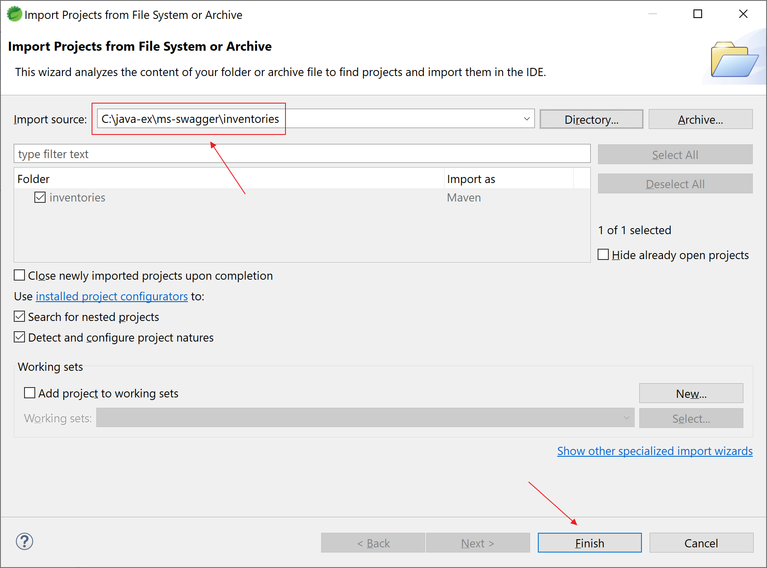

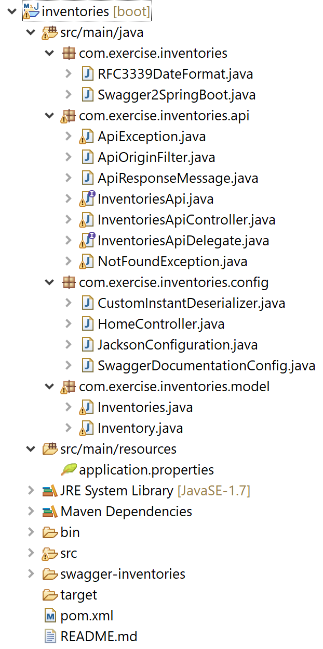

Add following dependency to your pom.xml

<dependency>

<groupId>javax.xml.bind</groupId>

<artifactId>jaxb-api</artifactId>

<version>2.3.1</version>

</dependency>

If it is the first time you create a microservice, Maven will download some libraries from Maven repository. Please be patient while Maven download it for you

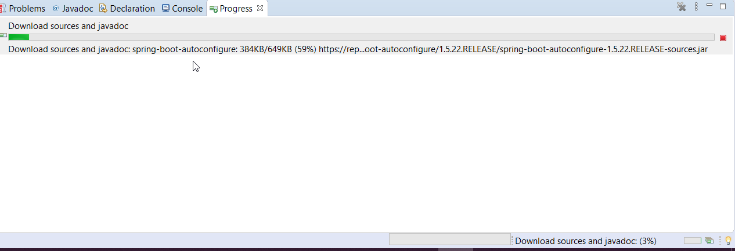

12. Take a look at the APIs that we’re going to implement. Open “InventoriesApi.java”:

Note:

addInventory() is for PUT: /inventories

getAllInventories() is for GET: /inventories

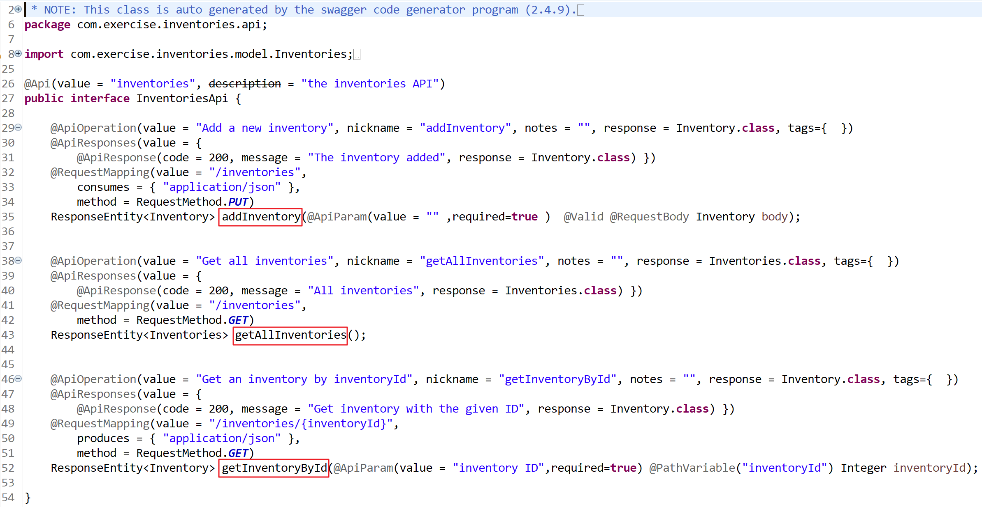 getInventoryById() is for GET: /inventories/{inventoryId}

13. Implement the above functions. InventoriesApiDelegate.java is an interface class that contains all the above methods. Let’s create a class to implement this interface:

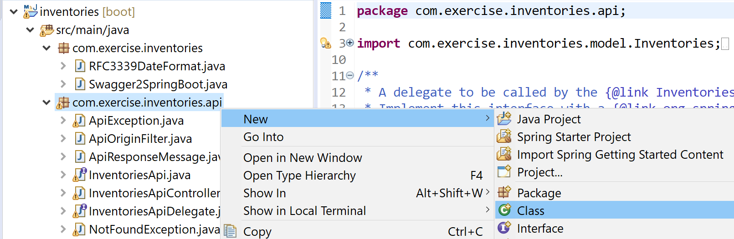13a. Create a class “InventoriesApiDelegateImpl” under package “com.exercise.inventories.api.impl”:

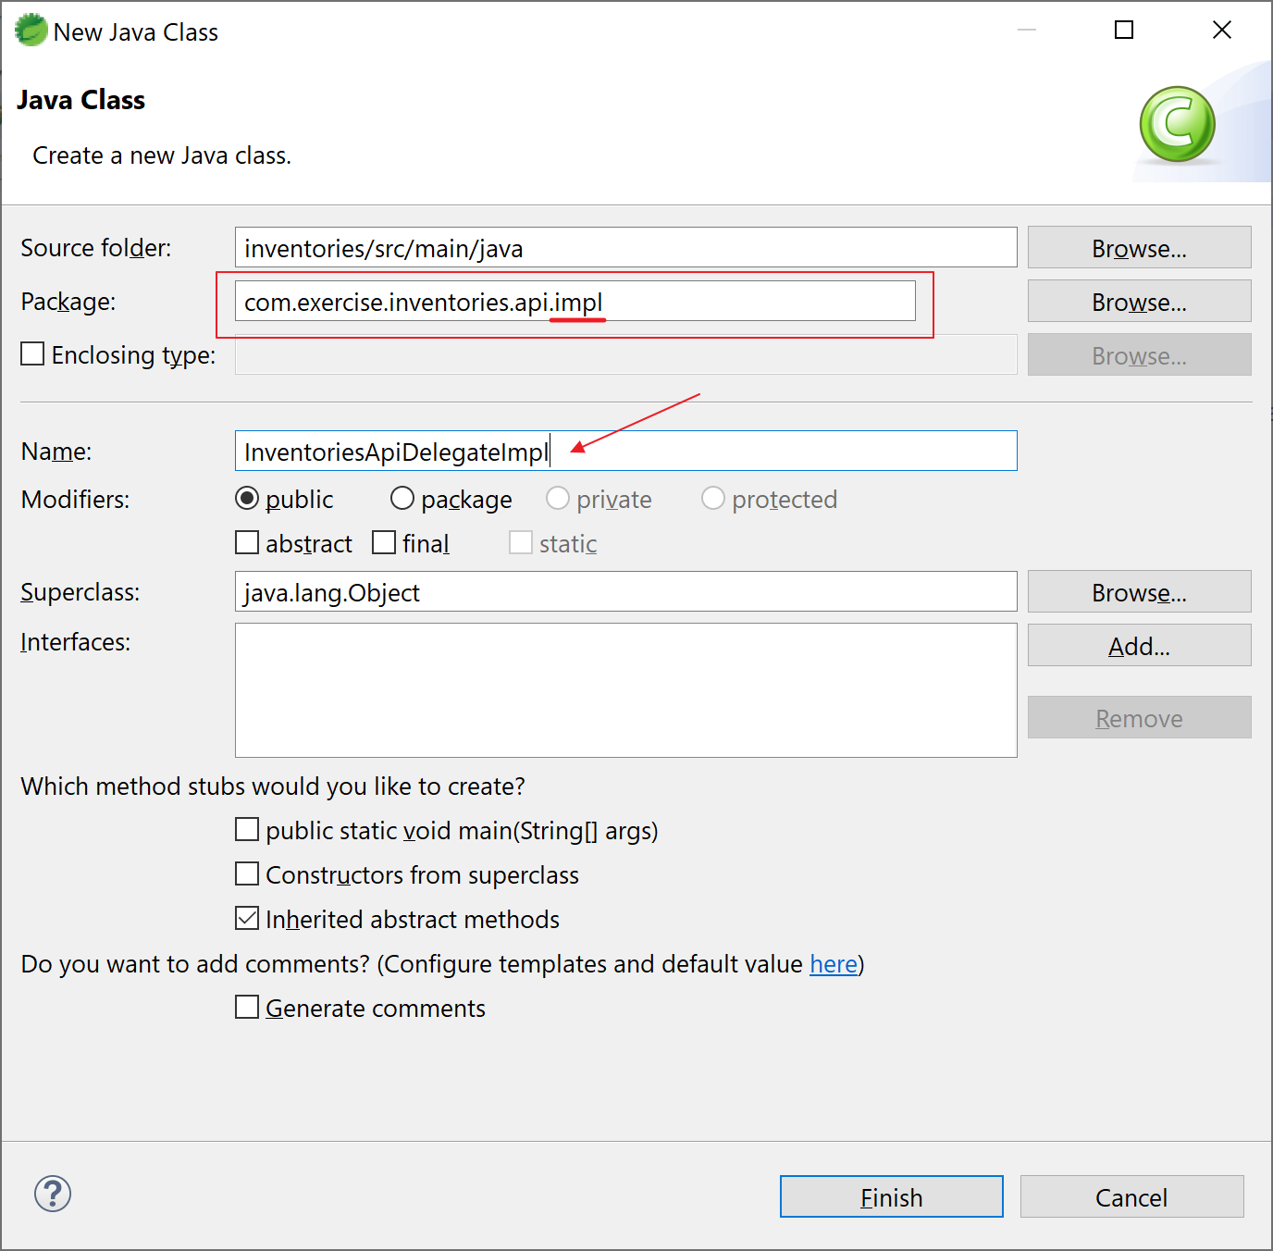

13b. Open the file and insert the following code:

package com.exercise.inventories.api.impl;

import org.springframework.http.ResponseEntity;

import com.exercise.inventories.api.InventoriesApiDelegate;

import com.exercise.inventories.model.Inventories;

import com.exercise.inventories.model.Inventory;

public class InventoriesApiDelegateImpl implements InventoriesApiDelegate {

@Override

public ResponseEntity<Inventory> addInventory(Inventory body) {

// TODO Auto-generated method stub

return null;

}

@Override

public ResponseEntity<Inventories> getAllInventories() {

// TODO Auto-generated method stub

return null;

}

@Override

public ResponseEntity<Inventory> getInventoryById(Integer inventoryId) {

// TODO Auto-generated method stub

return null;

}

}

Note: we don’t implement the functions at the moment, and we’re going to check the API connection first.

14. Define the above bean. Create a class “BeanConfig” under package “com.exercise.inventories.config”:

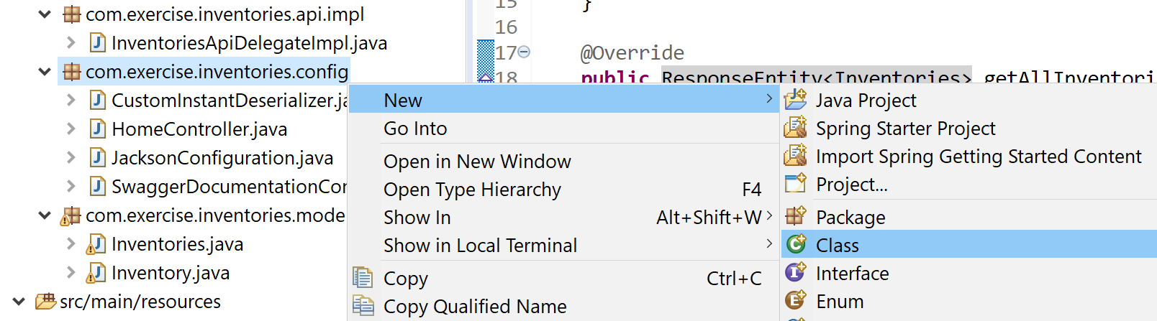

Add annotation @Configuration to the class and add the bean:

package com.exercise.inventories.config;

import org.springframework.context.annotation.Bean;

import org.springframework.context.annotation.Configuration;

import com.exercise.inventories.api.impl.InventoriesApiDelegateImpl;

@Configuration

public class BeanConfig {

@Bean

public InventoriesApiDelegateImpl inventoriesApi() {

return new InventoriesApiDelegateImpl();

}

}

Here’s the final structure of the project:

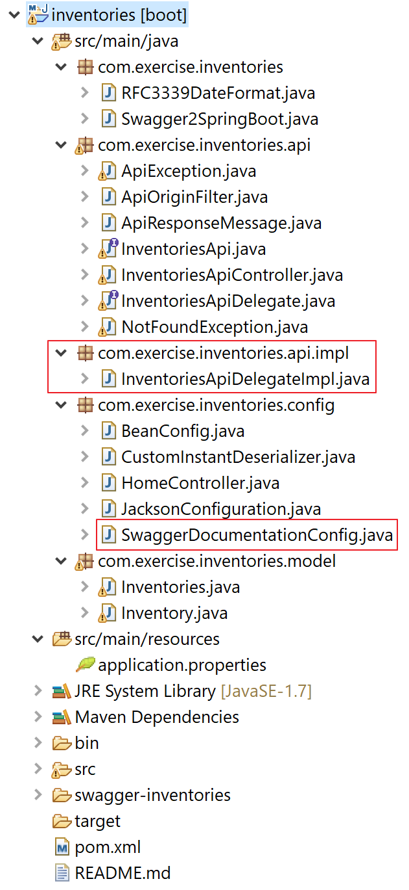

Add following to pom.xml

<dependency>

<groupId>javax.xml.bind</groupId>

<artifactId>jaxb-api</artifactId>

<version>2.3.1</version>

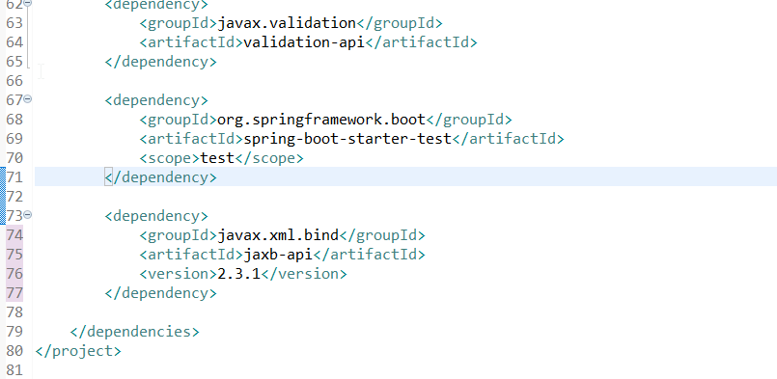</dependency>

15. Start the application in the following ways:

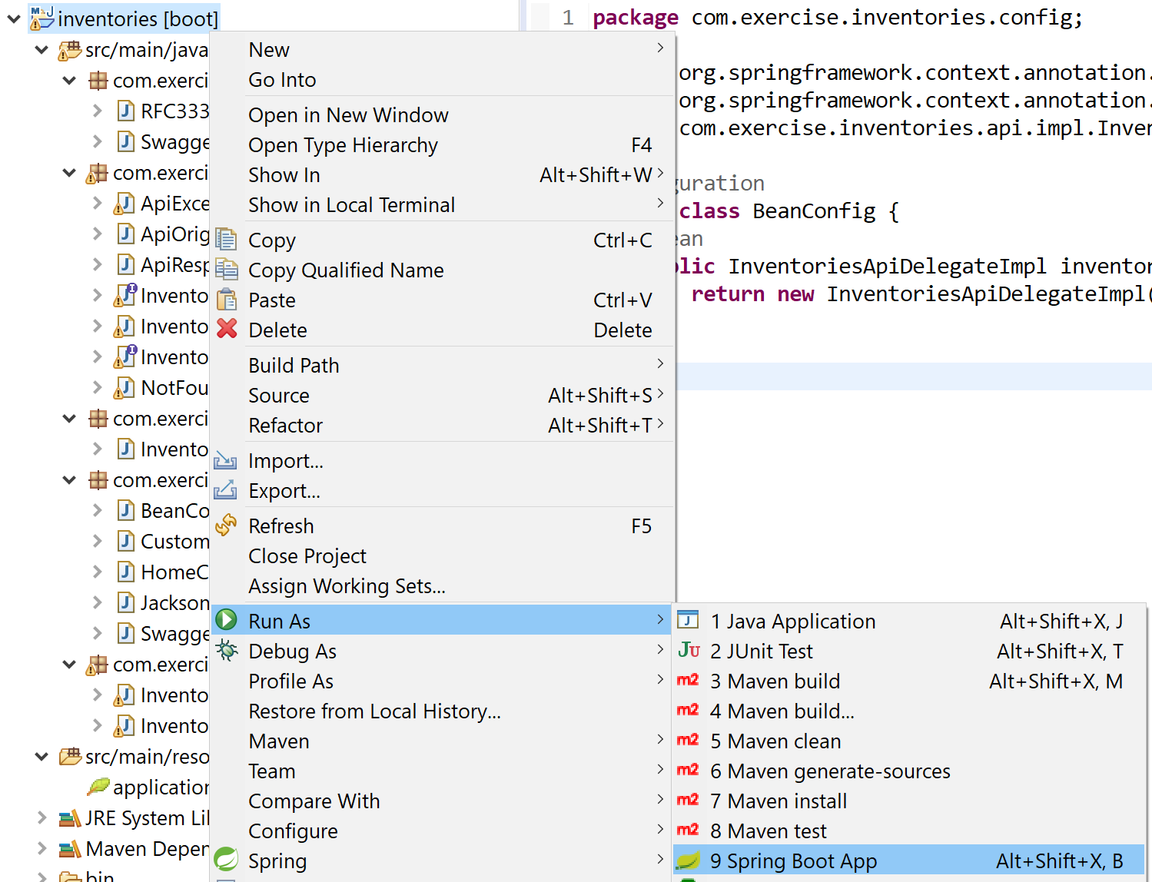15a. Method 1 - from STS, right click the project, select “Run As” and “Spring Boot App”:

15b. Stop the server from STS, click the “red square” icon to stop:

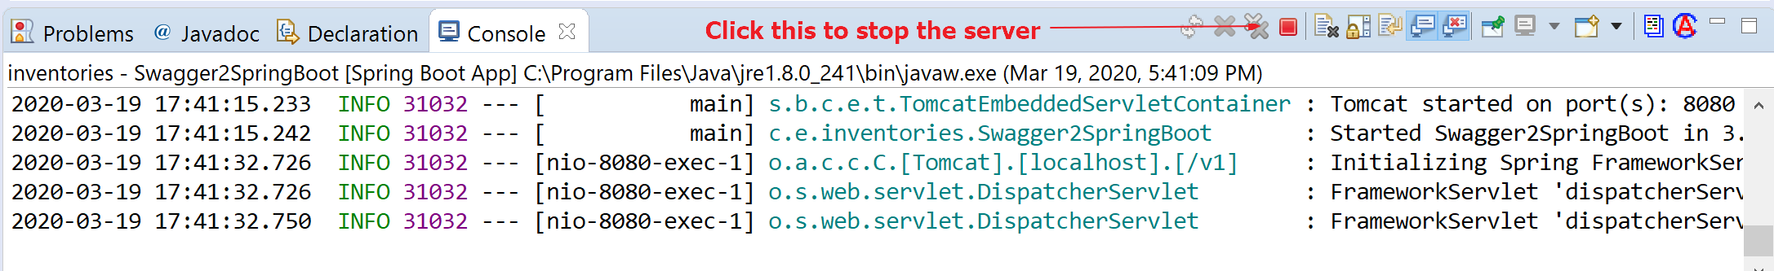

15c. Method 2 - start from command prompt, start a command prompt and change directory to your project, e.g. C:\java-ex\ms-swagger\inventories and run the following command:

C:\java-ex\ms-swagger\inventories>**mvn spring-boot:run**

15d. Stop the server from command prompt, in the command prompt that you start the server, press Ctrl-C.

16. Examine the application. Open a browser and visit the following URL:

<http://localhost:8080/v1/swagger-ui.html>

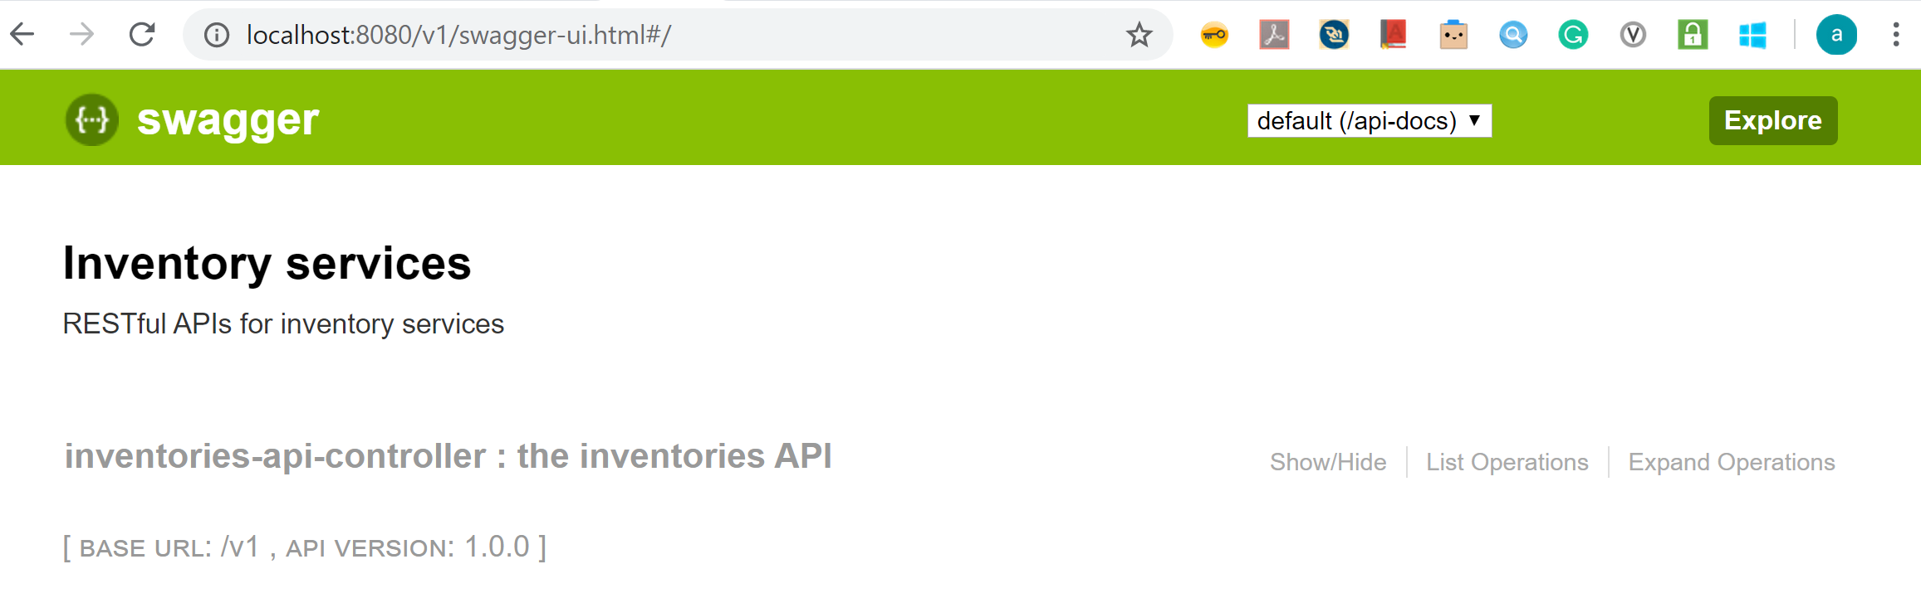

17. Congratulation! Try this one if you have problem with this exercise:



# Exercise 2 – Inventory Microservices (Advance)

Enable Database connection in Microservices

## Prerequisites:

Java installed (e.g. JDK 11)

Maven installed (e.g. version 3.6.3)

Spring Tool Suite (STS) (e.g. 4.5.1)

Exercise 1 is finished

1. Add persistence support by adding dependencies to pom.xml. Add the following code to pom.xml:

<dependency>

<groupId>org.springframework.boot</groupId>

<artifactId>spring-boot-starter-data-jpa</artifactId>

</dependency>

<dependency>

<groupId>org.hsqldb</groupId>

<artifactId>hsqldb</artifactId>

<scope>runtime</scope>

</dependency>

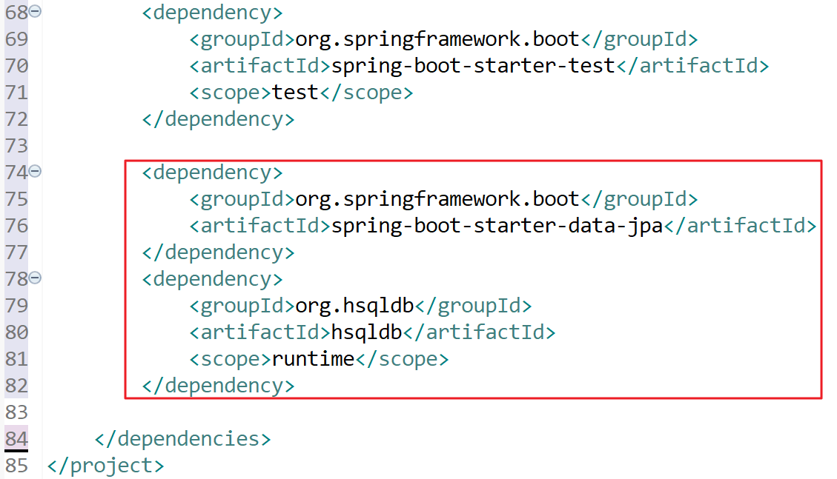

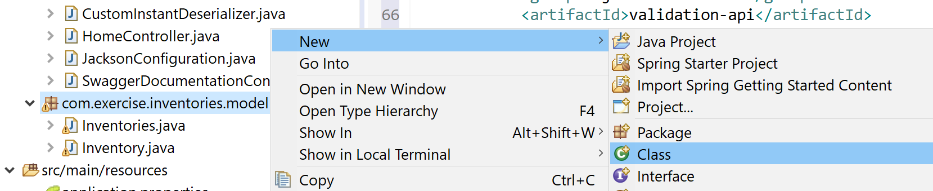2. Create an entity model for persistence. Create a class “InventoryEntity” under package “com.exercise.inventories.model”:

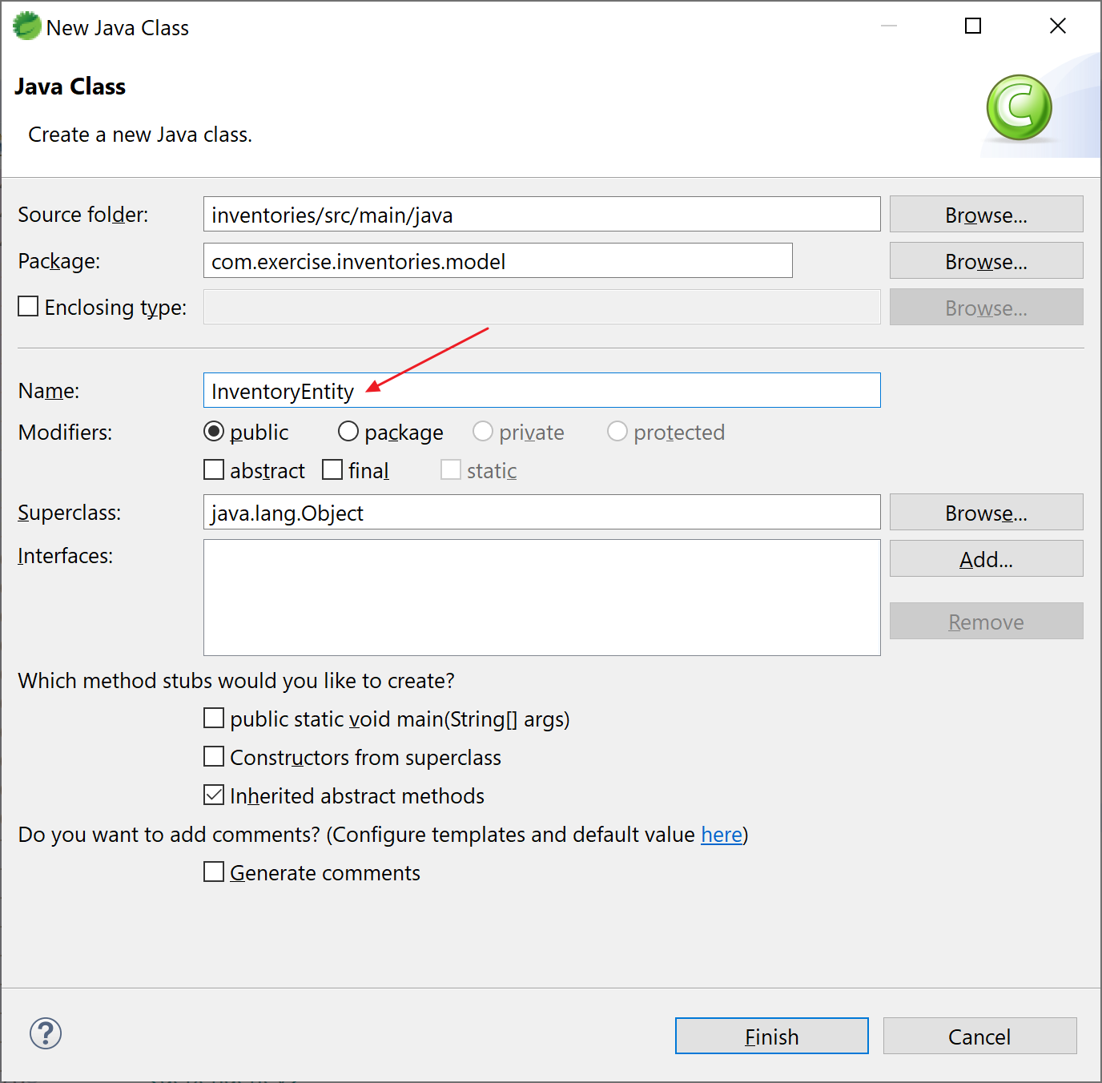

Here’s the content of the “InventoryEntity.java”:

package com.exercise.inventories.model;

import javax.persistence.Entity;

import javax.persistence.GeneratedValue;

import javax.persistence.GenerationType;

import javax.persistence.Id;

import javax.persistence.Table;

@Entity

@Table(name = "inventories")

public class InventoryEntity {

@Id

@GeneratedValue(strategy = GenerationType.AUTO)

private Integer inventoryId;

private String itemCode;

private Integer quantity;

private String status;

public Integer getInventoryId() {

return inventoryId;

}

public void setInventoryId(Integer inventoryId) {

this.inventoryId = inventoryId;

}

public String getItemCode() {

return itemCode;

}

public void setItemCode(String itemCode) {

this.itemCode = itemCode;

}

public Integer getQuantity() {

return quantity;

}

public void setQuantity(Integer quantity) {

this.quantity = quantity;

}

public String getStatus() {

return status;

}

public void setStatus(String status) {

this.status = status;

}

}

Note: import classes should be from javax.persistence.*

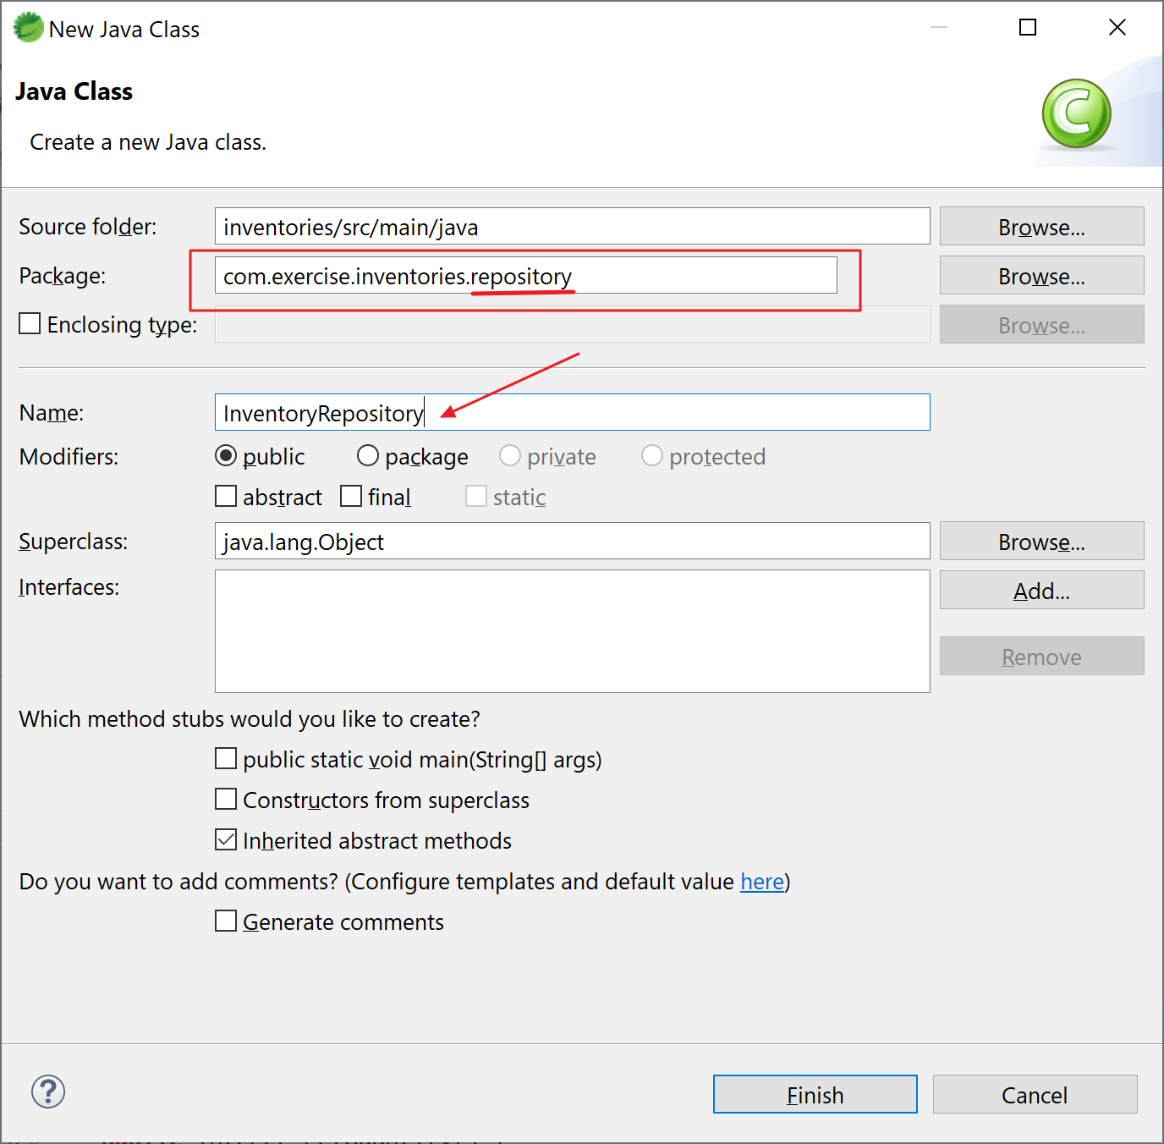3. Create the repository to access database. Create a class “InventoryRepository” under package “com.exercise.inventories.repository”:

Here’s the content of “InventoryRepository.java”:

package com.exercise.inventories.repository;

import org.springframework.data.jpa.repository.JpaRepository;

import com.exercise.inventories.model.InventoryEntity;;

public interface InventoryRepository extends JpaRepository<InventoryEntity, String> {

public InventoryEntity findByInventoryId(Integer id);

}

4. Create the service to call the repository (instead of access database directly). Create a class “InventoryService” under package “com.exercise.inventories.service”:

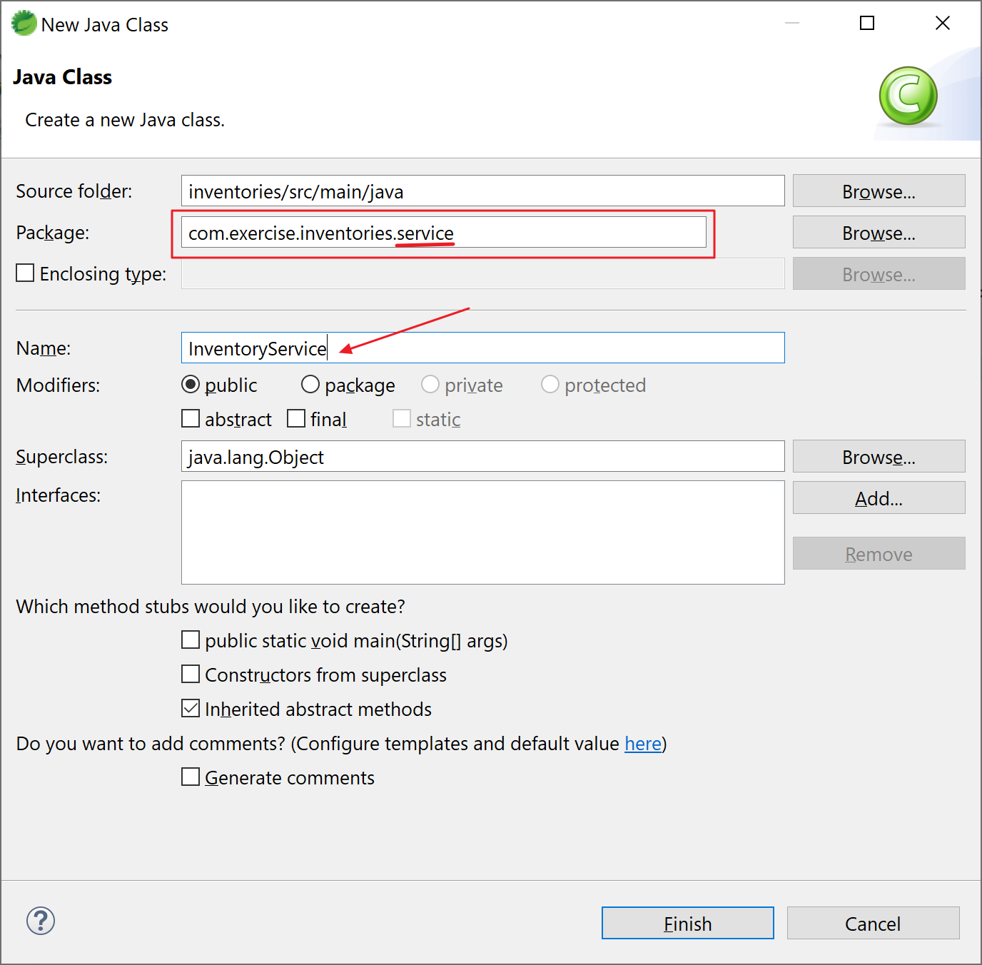

Here’s the content of “InventoryService.java”:

package com.exercise.inventories.service;

import java.util.List;

import org.springframework.beans.factory.annotation.Autowired;

import org.springframework.stereotype.Service;

import com.exercise.inventories.model.InventoryEntity;

import com.exercise.inventories.repository.InventoryRepository;

@Service

public class InventoryService {

@Autowired

InventoryRepository inventoryRepository;

public List<InventoryEntity> getAllInventories() {

List<InventoryEntity> inventories = inventoryRepository.findAll();

return inventories;

}

public InventoryEntity addInventory(InventoryEntity inventory) {

return inventoryRepository.save(inventory);

}

public InventoryEntity findByInventoryId(Integer id) {

return inventoryRepository.findByInventoryId(id);

}

}

5. The project structure should look like this:

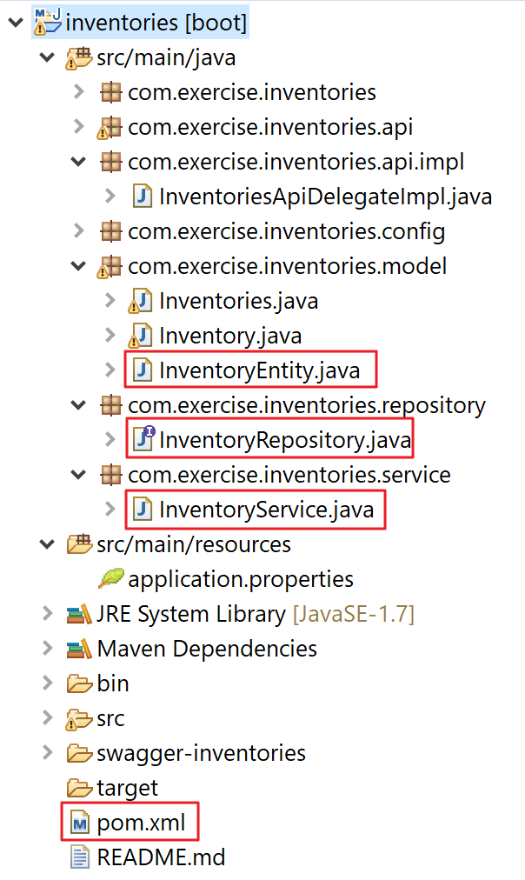

Note the highlighted files are files that created or modified in the above steps.

6. Let’s build the functionalities of the Inventory Services. In exercise 1, we don’t implement the API functions, now we add the business logic to the functions.

Open “InventoriesApiDelegateImpl.java” and modify the functions accordingly:

package com.exercise.inventories.api.impl;

import java.util.List;

import org.springframework.beans.factory.annotation.Autowired;

import org.springframework.http.HttpStatus;

import org.springframework.http.ResponseEntity;

import com.exercise.inventories.api.InventoriesApiDelegate;

import com.exercise.inventories.model.Inventories;

import com.exercise.inventories.model.Inventory;

import com.exercise.inventories.model.InventoryEntity;

import com.exercise.inventories.service.InventoryService;

public class InventoriesApiDelegateImpl implements InventoriesApiDelegate {

@Autowired

InventoryService inventoryService;

@Override

public ResponseEntity<Inventory> addInventory(Inventory body) {

InventoryEntity inventoryEntity = convertFrom(body);

inventoryEntity.setStatus("INITIAL");

inventoryEntity = inventoryService.addInventory(inventoryEntity);

Inventory inventory = convertFrom(inventoryEntity);

return new ResponseEntity<>(inventory, HttpStatus.OK);

}

@Override

public ResponseEntity<Inventories> getAllInventories() {

List<InventoryEntity> listInventoryEntity = inventoryService.getAllInventories();

Inventories inventories = new Inventories();

for (InventoryEntity ie : listInventoryEntity) {

Inventory inventory = convertFrom(ie);

inventories.addDataItem(inventory);

}

return new ResponseEntity<>(inventories, HttpStatus.OK);

}

@Override

public ResponseEntity<Inventory> getInventoryById(Integer inventoryId) {

InventoryEntity ie = inventoryService.findByInventoryId(inventoryId);

Inventory inventory = convertFrom(ie);

return new ResponseEntity<>(inventory, HttpStatus.OK);

}

private InventoryEntity convertFrom(Inventory inventory) {

InventoryEntity inventoryEntity = new InventoryEntity();

inventoryEntity.setInventoryId(inventory.getInventoryId());

inventoryEntity.setItemCode(inventory.getItemCode());

inventoryEntity.setQuantity(inventory.getQuantity());

inventoryEntity.setStatus(inventory.getStatus());

return inventoryEntity;

}

private Inventory convertFrom(InventoryEntity inventoryEntity) {

Inventory inventory = new Inventory();

inventory.setInventoryId(inventoryEntity.getInventoryId());

inventory.setItemCode(inventoryEntity.getItemCode());

inventory.setQuantity(inventoryEntity.getQuantity());

inventory.setStatus(inventoryEntity.getStatus());

return inventory;

}

}

Note: please study the logic of the API functions.

addInventory() is to store an inventory to database

getAllInventoies() to get all inventories from database

getInventoryById is to get an inventory by its ID

convertFrom() is a tool to convert between the API parameters and entity model

7. Save all your work and restart your application.

8. Examine the functions. Open a browser and visit:

<http://localhost:8080/v1/swagger-ui.html>

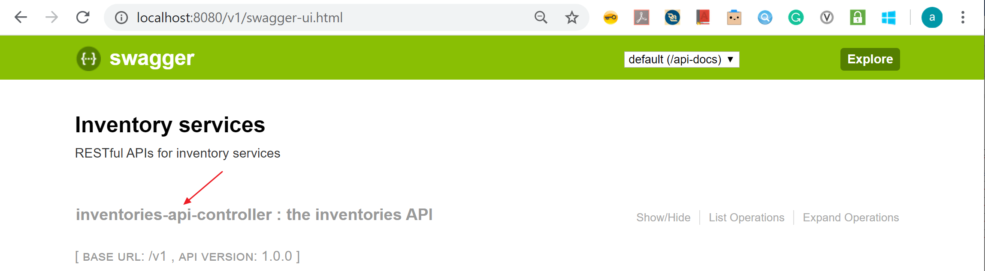Click “inventories-api-controller”, a list of all APIs will show:

8a. PUT /inventories, Click the second one:

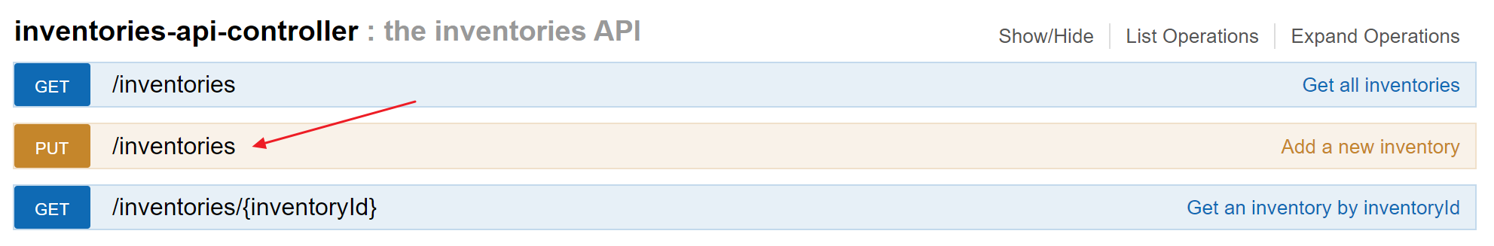

Input the following JSON and click “Try it out!”:

{

"itemCode": "item-001",

"quantity": 99

}

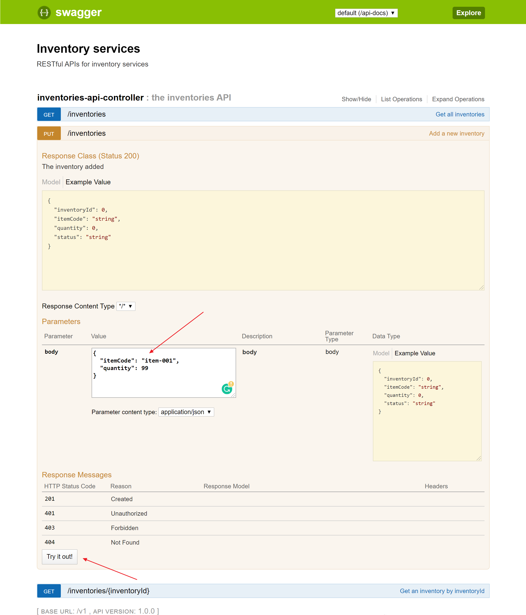

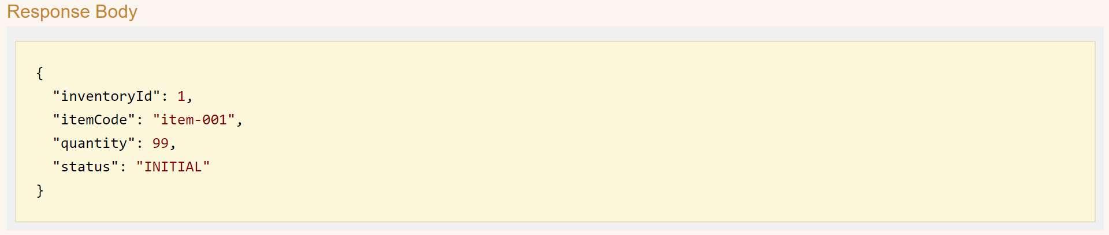You should see the response from API:

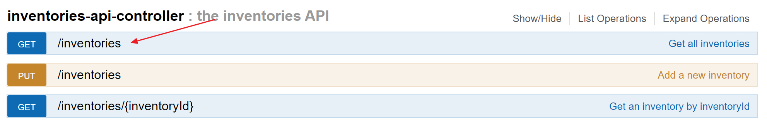8b. GET /inventories, click the first one:

We don’t need to input parameter, so click “Try it out!” directly:

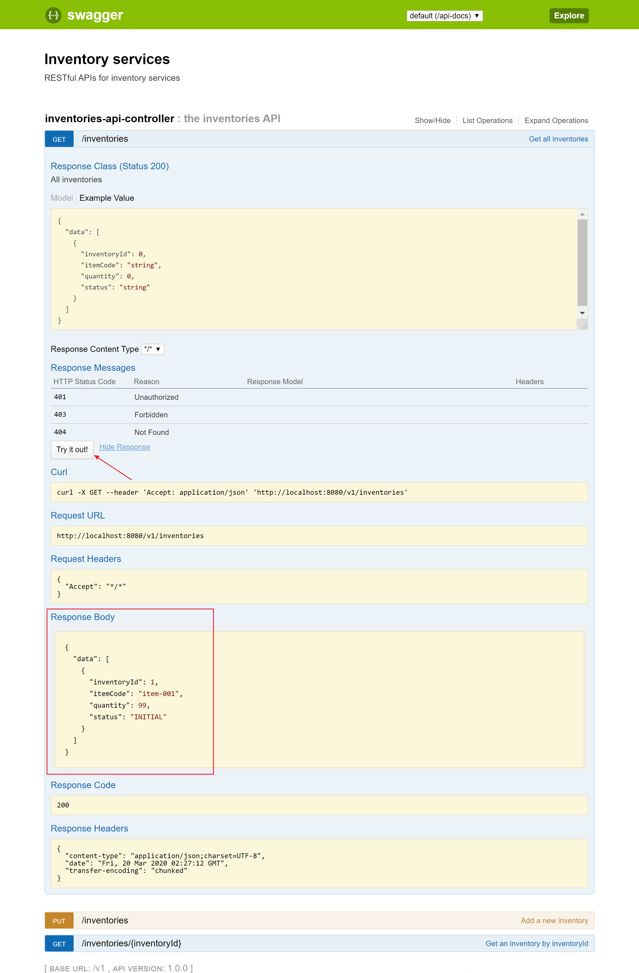

8c. GET /inventories/{inventoryId}, click the third one:

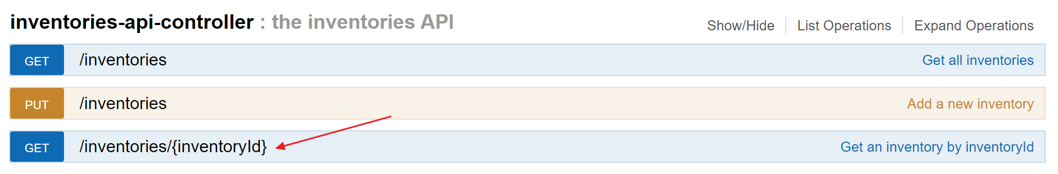

Input “1” to the parameter “inventoryId” and click “Try it out!”:

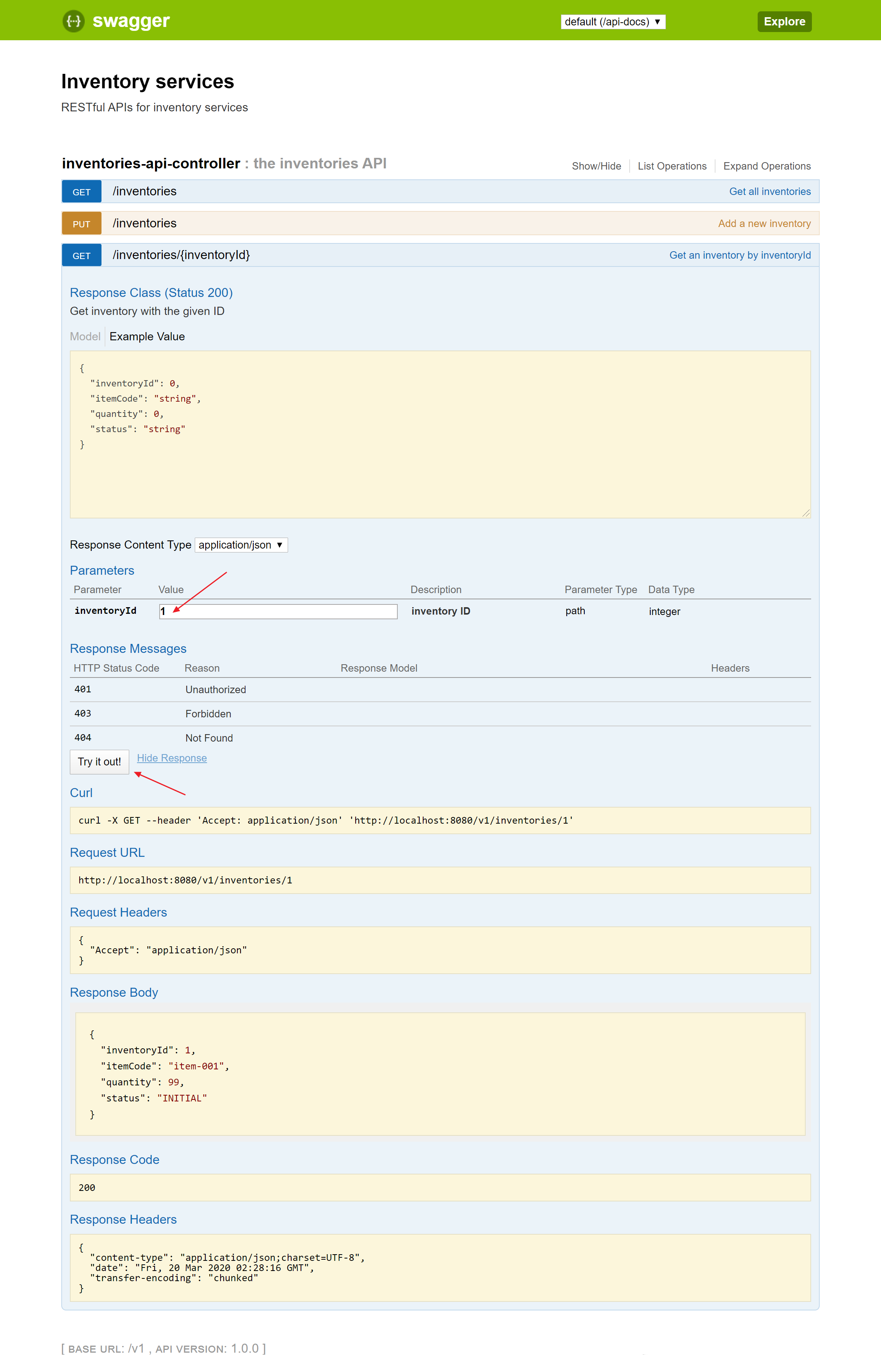9. Congratulations! Try this one if you have problem with this exercise:



# Exercise 3 – Microservices (Basic Authentication)

In this exercise, we are going to add authentication to protect the microservices

Prerequisites:

Java installed (e.g. JDK 1.8)

Maven installed (e.g. version 3.6.3)

Spring Tool Suite (STS) (e.g. 4.5.1)

Postman (e.g. version 7.20.1)

Exercise 2 is finished

1. Add dependencies of Spring Security to pom.xml:

<dependency>

<groupId>org.springframework.boot</groupId>

<artifactId>spring-boot-starter-security</artifactId>

</dependency>

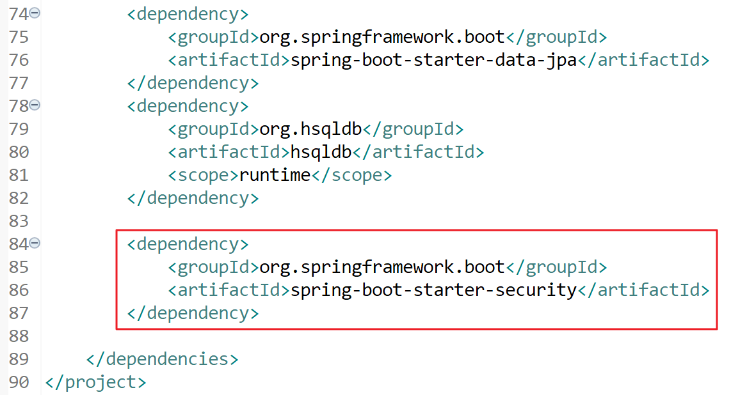

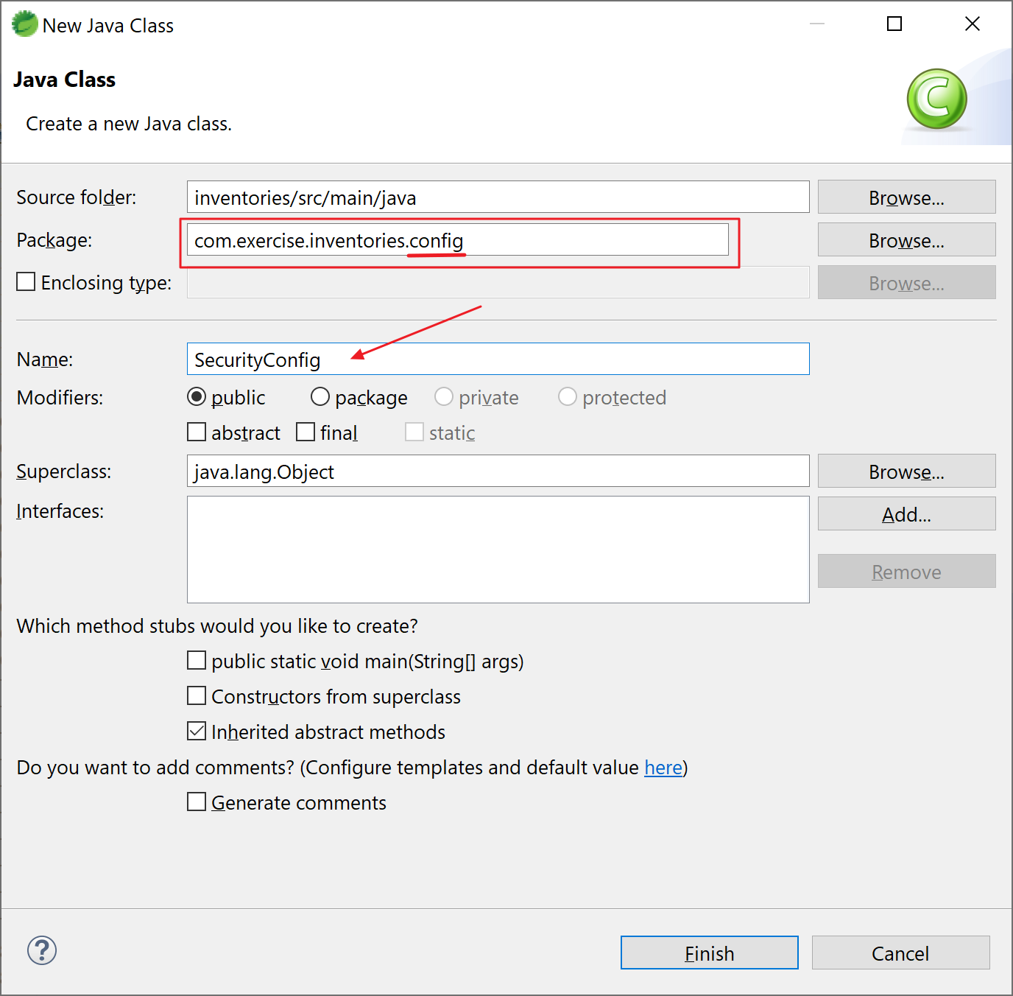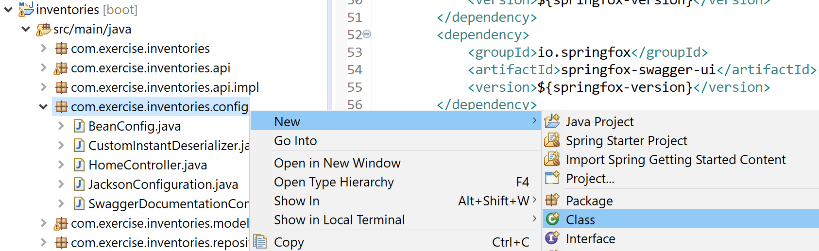2. Configure the Spring Security. Create the class “SecurityConfig” under package “”:

Open the file and insert the following code:

package com.exercise.inventories.config;

import org.springframework.beans.factory.annotation.Value;

import org.springframework.context.annotation.Bean;

import org.springframework.context.annotation.Configuration;

import org.springframework.http.HttpMethod;

import org.springframework.security.config.annotation.web.builders.HttpSecurity;

import org.springframework.security.config.annotation.web.configuration.WebSecurityConfigurerAdapter;

import org.springframework.security.core.userdetails.User;

import org.springframework.security.core.userdetails.UserDetailsService;

import org.springframework.security.crypto.bcrypt.BCryptPasswordEncoder;

import org.springframework.security.crypto.password.PasswordEncoder;

import org.springframework.security.provisioning.InMemoryUserDetailsManager;

@Configuration

public class SecurityConfig extends WebSecurityConfigurerAdapter {

@Value( "${secrets.acl.name.user}" )

private String nameUser;

@Value( "${secrets.acl.pass.user}" )

private String passUser;

@Value( "${secrets.acl.role.user}" )

private String roleUser;

@Value( "${secrets.acl.name.admin}" )

private String nameAdmin;

@Value( "${secrets.acl.pass.admin}" )

private String passAdmin;

@Value( "${secrets.acl.role.admin}" )

private String roleAdmin;

@Override

protected void configure(HttpSecurity http) throws Exception {

http

.csrf().disable()

.authorizeRequests().anyRequest().authenticated()

.and()

.httpBasic();

}

@Bean

public UserDetailsService userDetailsService() {

InMemoryUserDetailsManager manager = new InMemoryUserDetailsManager();

manager.createUser(User.withUsername(nameUser).password(passwordEncoder().encode(passUser)).roles(roleUser).build());

manager.createUser(User.withUsername(nameAdmin).password(passwordEncoder().encode(passAdmin)).roles(roleAdmin).build());

return manager;

}

@Bean

public PasswordEncoder passwordEncoder() {

return new BCryptPasswordEncoder();

}

}

Note:

http.authorizeRequests().anyRequest().authenticated() makes all requests need to authenticate

userDetailsService() is used to get user credentials

passwordEncoder() is for encrypt the passwords

we retrieve user name and password from “application.properties” to simulate the secrets manager.

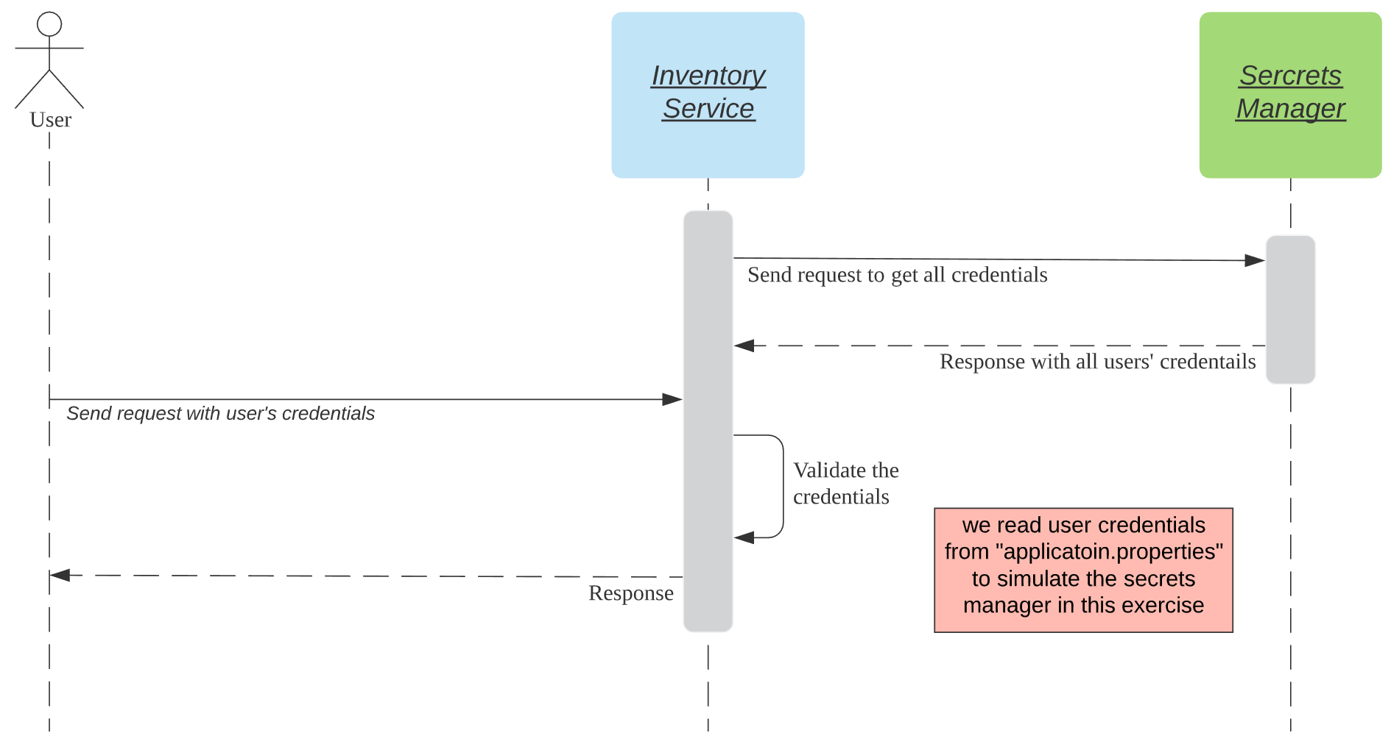

3. To simulate the secrets manager, we configure the users’ credentials in “application.properties”. Open the file (…/src/main/resources/application.properties) and add the following configurations:

# simulate secrets manager for user

secrets.acl.name.user=user

secrets.acl.pass.user=password1

secrets.acl.role.user=USER

# simulate secrets manager for admin

secrets.acl.name.admin=admin

secrets.acl.pass.admin=password2

secrets.acl.role.admin=ADMIN

4. Modify the server port number to 8100 (we are going to implement several services, change port number to avoid port collision). In “application.properties”, change server.port from 8080 to 8100:

from

server.port=8080

to

server.port=8100

the file “application.properties” should look like this:

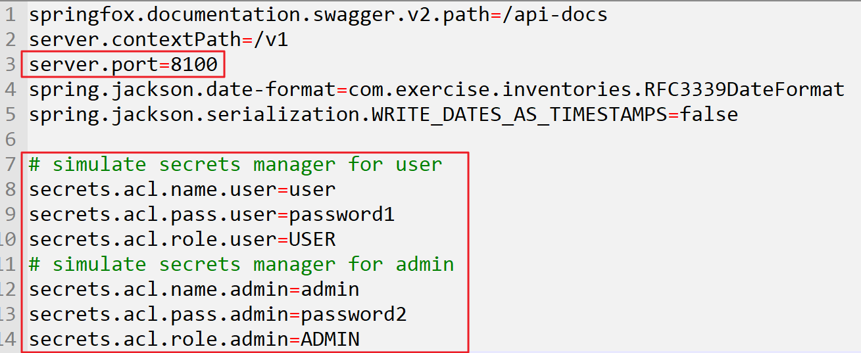

5. Restart the application and examine the results in Postman.

5a. Open Postman and input the following request:

PUT http://localhost:8100/v1/inventories

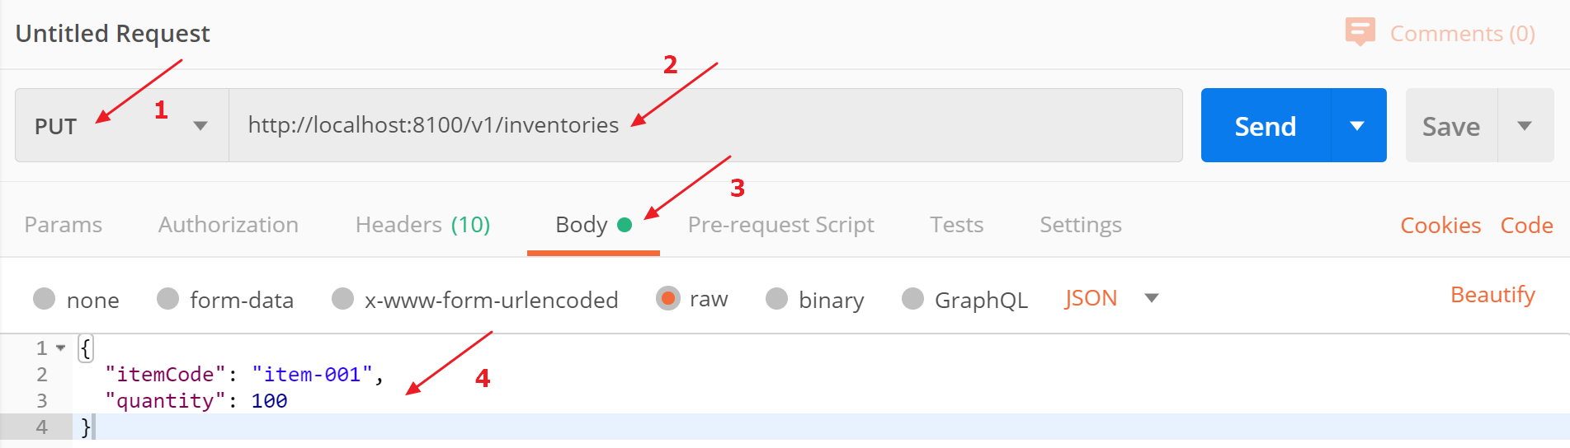

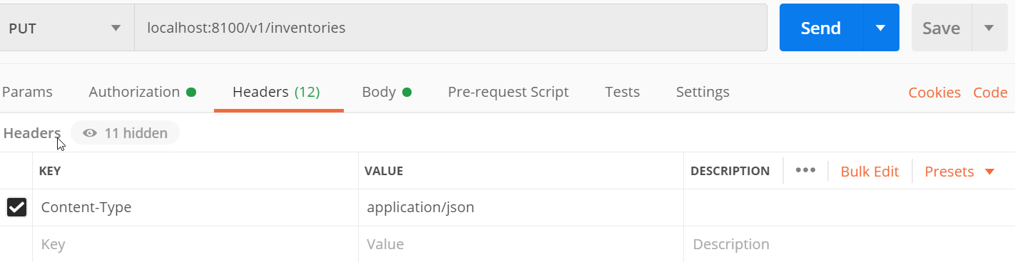 Also, add **Content-Type** header with value **application/json**

In Body tab, select **raw** and **JSON**, input the following request body:

{

"itemCode": "item-001",

"quantity": 100

}

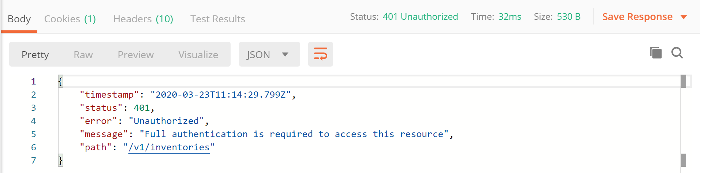Click Send button. We get the following error:

That’s absolutely correct! We set all requests must be authenticated in the previous steps.

Let’s input the credentials and send the request again:

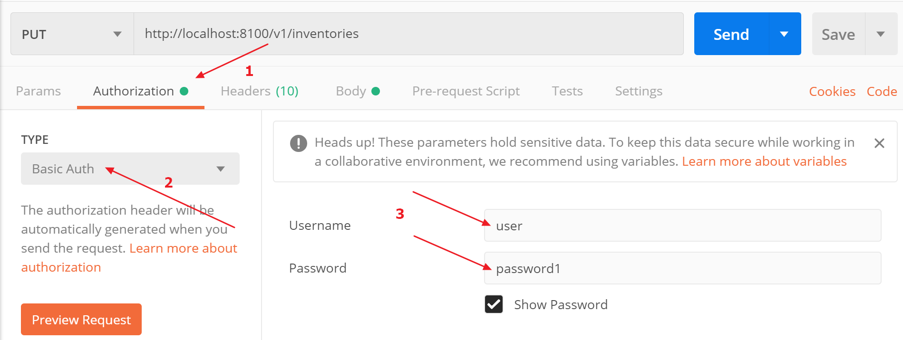

Now we get the response successfully:

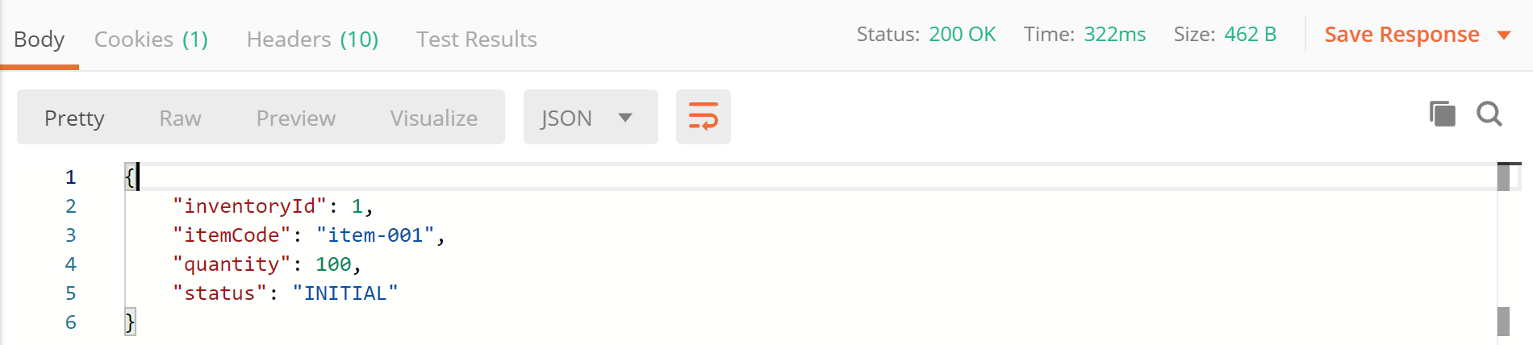

5b. Examine the request:

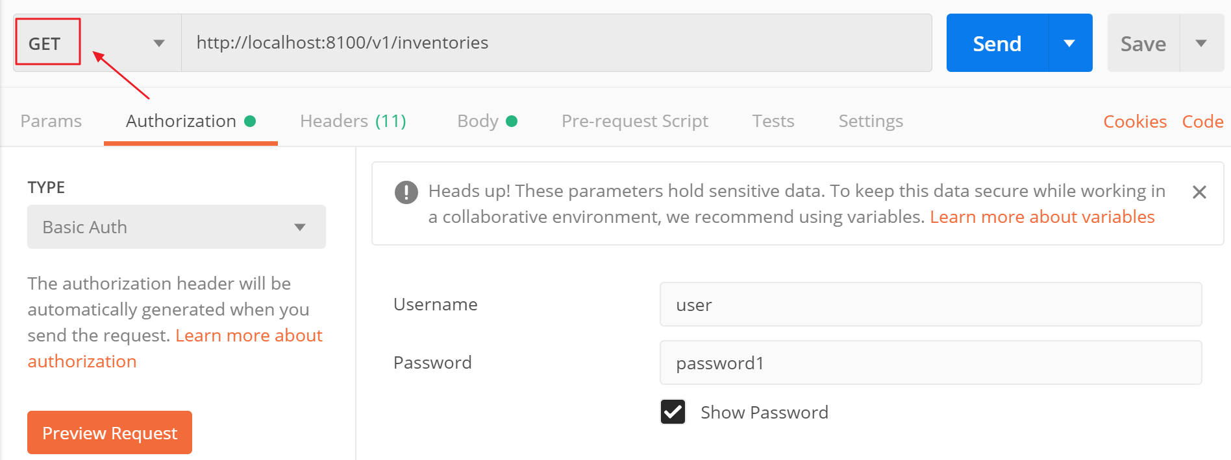 GET http://localhost:8100/v1/inventories

Change the method to GET and keep the credentials unchanged. Click the Send button:

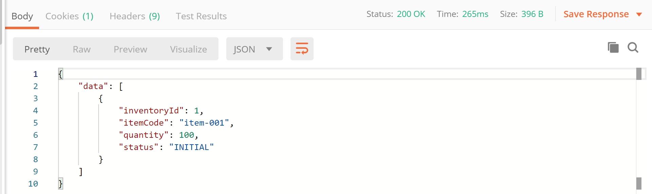

5c. Examine the request:

GET http://localhost:8100/v1/inventories/{inventoryId}

In the above results, we know that there’s an inventory ID is 1. Let’s send a request with invnetoryId 1:

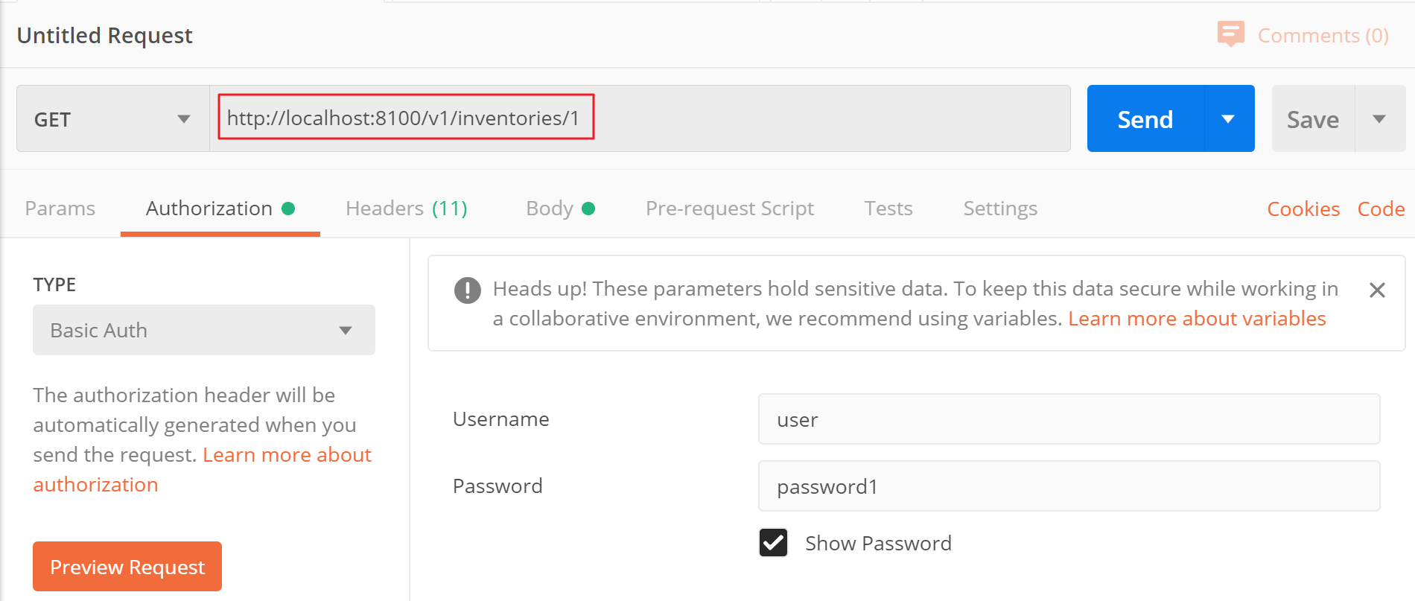 GET http://localhost:8100/v1/inventories/1

And we should get the response successfully:

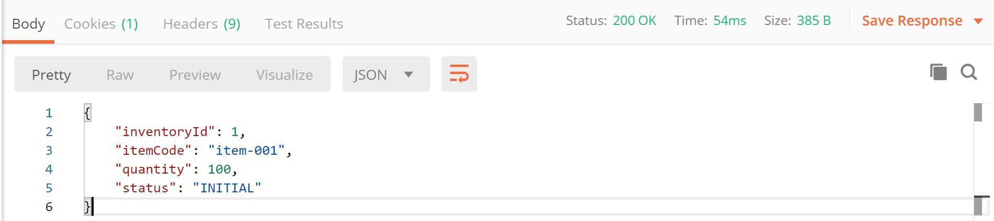

6. In real business, we may need more control over the APIs. Let’s configure the APIs’ authentication using ROLE. Let’s open the SecurityConfig.java and modify the following code:

from

.authorizeRequests().anyRequest().authenticated()

to .authorizeRequests().antMatchers(HttpMethod.GET,"/inventories/**").hasAnyRole("ADMIN","USER")

.and()

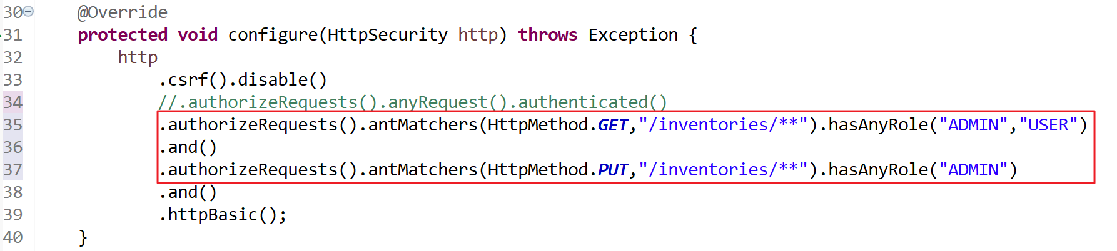 .authorizeRequests().antMatchers(HttpMethod.PUT,"/inventories/**").hasAnyRole("ADMIN")

Note: in these settings:

GET /inventories/** can be access with ROLE: ADMIN and USER;

PUT /inventories/** can be access with ROLE: ADMIN

7. Restart the application and verify the results in Postman:

7a. Examine the request:

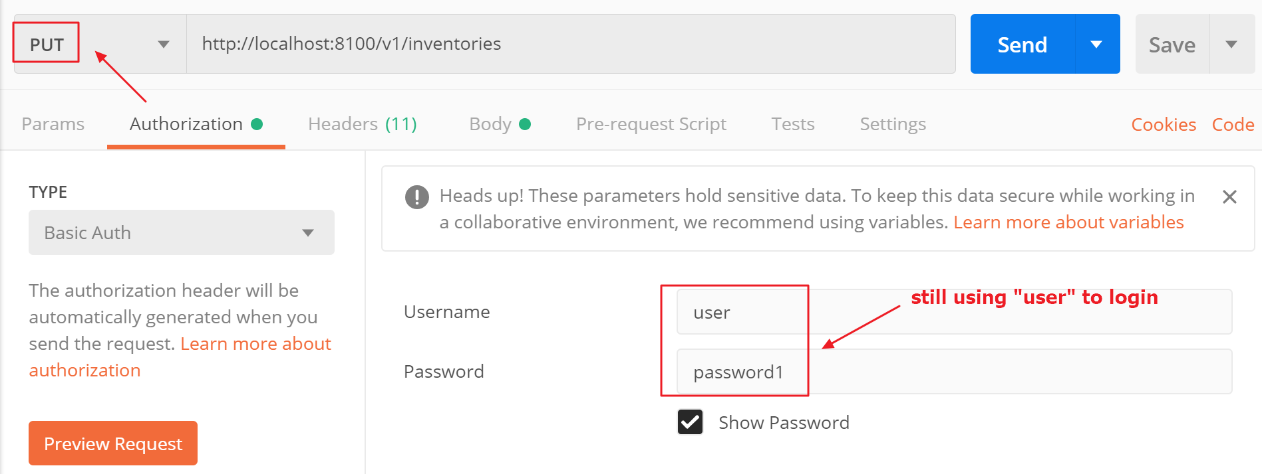 PUT http://localhost:8100/v1/inventories

We still use “user” to login and the request body keeps unchanged:

{

"itemCode": "item-001",

"quantity": 100

}

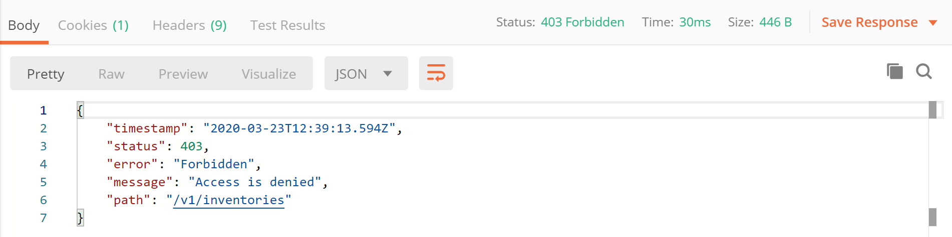

We get “Access is denied” error this time. This is an expected result because “user” has the role “USER” which is not allowed to access “PUT /inventories/**”. Let’s use “admin” credentials to send the request again:

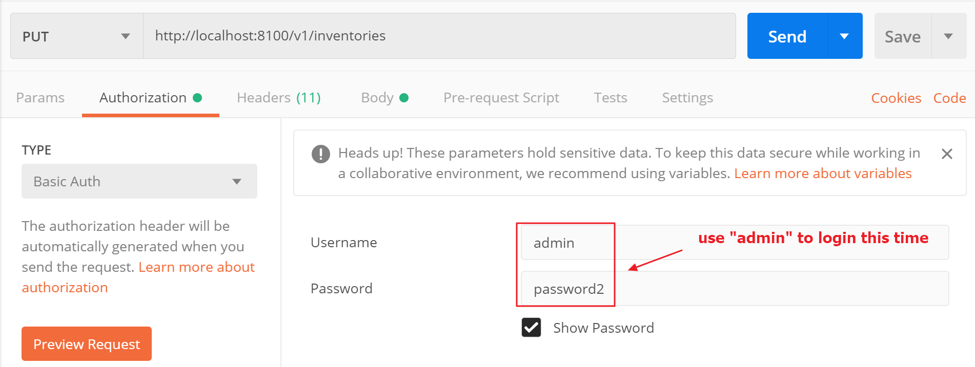

Click the Send button, and we should get the response successfully:

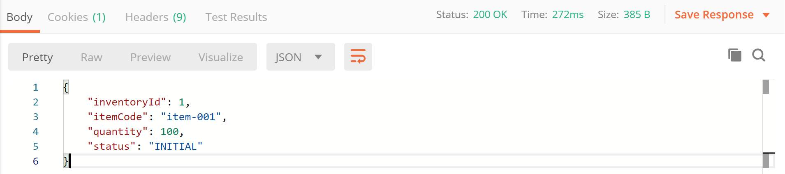

7b. Examine the request:

GET http://localhost:8100/v1/inventories

GET http://localhost:8100/v1/inventories/1

Try to use different credentials to access these APIs and see if you can get the responses.

Congratulations, if your configurations are correct, you should access the above APIs (the settings are allowed both ADMIN and USER role to access).

Try this one if you have problem with this exercise:



# Exercise 4 – Order Microservices

Prerequisites:

Java installed (e.g. JDK 11)

Maven installed (e.g. version 3.6.3)

Spring Tool Suite (STS) (e.g. 4.5.1)

JAR file for swagger codegen

Generali-4-Microservices-exercises.docx is finished

1. Create a new folder for the project orders services, e.g. C:\java-ex\ms-swagger\orders.

2. Create a new folder store the swagger files, e.g. C:\java-ex\ms-swagger\orders\swagger-orders.

3. Create a swagger specification file “swagger-orders.yml” under the folder you created in the above step, e.g.

C:\java-ex\ms-swagger\orders\swagger-orders\swagger-orders.yml

Here’s the content of swagger-orders.yml:

openapi: 3.0.1

info:

title: Order services

description: RESTful APIs for order services

version: 1.0.0

servers:

- url: http://localhost/v1

paths:

/orders:

get:

summary: Get all orders

operationId: getAllOrders

responses:

200:

description: All orders

content:

'*/*':

schema:

$ref: '#/components/schemas/Orders'

application/json:

example: |-

{

data: [

{

orderId: ,

userId: 1,

itemCode: "1",

unitPrice: 1.0,

quantity: 1,

status: ""

}

]

}

put:

summary: Add a new order

operationId: addOrder

requestBody:

content:

application/json:

schema:

$ref: '#/components/schemas/Order'

required: true

responses:

200:

description: The order added

content:

'*/*':

schema:

$ref: '#/components/schemas/Order'

application/json:

example: |-

{

data: [

{

orderId: 1,

userId: 1,

itemCode: "1",

unitPrice: 1.0,

quantity: 1,

status: "INITIAL"

}

]

}

x-codegen-request-body-name: body

/orders/{orderId}:

get:

summary: Get an order by orderId

operationId: getOrderById

parameters:

- name: orderId

in: path

description: order ID

required: true

schema:

type: integer

responses:

200:

description: Get order with the given ID

content:

application/json:

schema:

$ref: '#/components/schemas/Order'

example: |-

{

orderId: 1,

userId: 1,

itemCode: "1",

unitPrice: 1.0,

quantity: 1,

status: "INITIAL"

}

components:

schemas:

Order:

properties:

orderId:

type: integer

userId:

type: integer

itemCode:

type: string

unitPrice:

type: number

quantity:

type: integer

status:

type: string

Orders:

type: object

properties:

data:

type: array

items:

$ref: '#/components/schemas/Order'

securitySchemes:

basic_auth:

type: http

scheme: basic

api_key:

type: apiKey

name: api_key

in: header

Note:

this specification defines the API’s paths, requests and responses, etc.

you may paste this specification to [https://editor.swagger.io](https://editor.swagger.io/) to view the API online

4. Create a configuration file “config-orders.json” under the same folder of above step, e.g.

C:\java-ex\ms-swagger\orders\swagger-orders\config-orders.json

Here’s the content of config-orders.json:

{

"apiPackage": "com.exercise.orders.api",

"groupId":"com.exercise.orders",

"artifactId": "order-services",

"basePackage": "com.exercise.orders",

"configPackage": "com.exercise.orders.config",

"modelPackage": "com.exercise.orders.model",

"language": "spring-boot",

"useRxJava":"true",

"delegatePattern": "true",

"hideGenerationTimestamp": "true"

}

5. Copy the codegen JAR file (swagger-codegen-cli-3.0.18.jar) to the projects directory.

(the JAR file should be already there if you did the exercises of Generali-4-Microservices-exercises.docx)

C:\java-ex\ms-swagger\swagger-codegen-cli-3.0.18.jar

Note: if you don’t have the JAR file, you may download from here:

<https://repo1.maven.org/maven2/io/swagger/swagger-codegen-cli/>

6. Now the structure of the project should look like this:

C:\JAVA-EX\MS-SWAGGER

│ swagger-codegen-cli-3.0.18.jar

│

└───orders

└───swagger-orders

config-orders.json

swagger-orders.yml

7. Start a command prompt and change directory to the orders project, e.g.

cd C:\java-ex\ms-swagger\orders

8. Run the following command to generate the Java code:

java -jar ../swagger-codegen-cli-3.0.18.jar generate -i swagger-orders/swagger-orders.yml -c swagger-orders/config-orders.json -l spring

Note:

-i specify the swagger specification source file

-c specify the configuration file

-l specify the generated programming language

Here’s the materials FYR:



9. The Java code should be generated with the following structure:

C:\JAVA-EX\MS-SWAGGER\ORDERS

│ .swagger-codegen-ignore

│ pom.xml

│ README.md

│

├───.swagger-codegen

│ VERSION

│

├───src

│ └───main

│ ├───java

│ │ └───com

│ │ └───exercise

│ │ └───orders

│ │ │ RFC3339DateFormat.java

│ │ │ Swagger2SpringBoot.java

│ │ │

│ │ ├───api

│ │ │ ApiException.java

│ │ │ ApiOriginFilter.java

│ │ │ ApiResponseMessage.java

│ │ │ NotFoundException.java

│ │ │ OrdersApi.java

│ │ │ OrdersApiController.java

│ │ │ OrdersApiDelegate.java

│ │ │

│ │ ├───config

│ │ │ CustomInstantDeserializer.java

│ │ │ HomeController.java

│ │ │ JacksonConfiguration.java

│ │ │ SwaggerDocumentationConfig.java

│ │ │

│ │ └───model

│ │ Order.java

│ │ Orders.java

│ │

│ └───resources

│ application.properties

│

└───swagger-orders

config-orders.json

generate-api-orders.txt

swagger-orders.yml

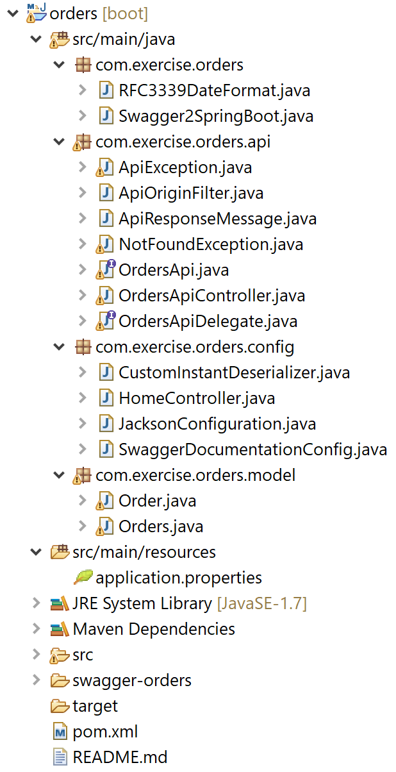10. Import the project to STS. Start STS, click “File”, select “Open Projects from File System…” and find your project to import:

Add following dependency to your pom.xml

<dependency>

<groupId>javax.xml.bind</groupId>

<artifactId>jaxb-api</artifactId>

<version>2.3.1</version>

</dependency>

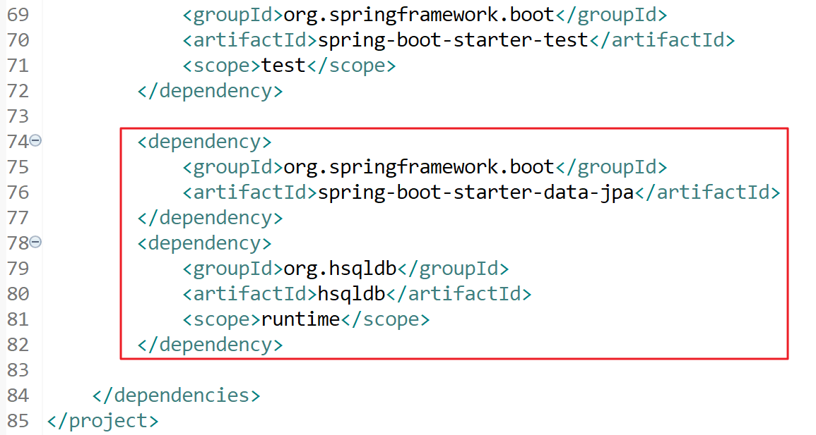11. Add persistence support by adding dependencies to pom.xml. Add the following code to pom.xml:

<dependency>

<groupId>org.springframework.boot</groupId>

<artifactId>spring-boot-starter-data-jpa</artifactId>

</dependency>

<dependency>

<groupId>org.hsqldb</groupId>

<artifactId>hsqldb</artifactId>

<scope>runtime</scope>

</dependency>

12. Create an entity model for persistence. Create a class “OrderEntity” under package “com.exercise.orders.model”:

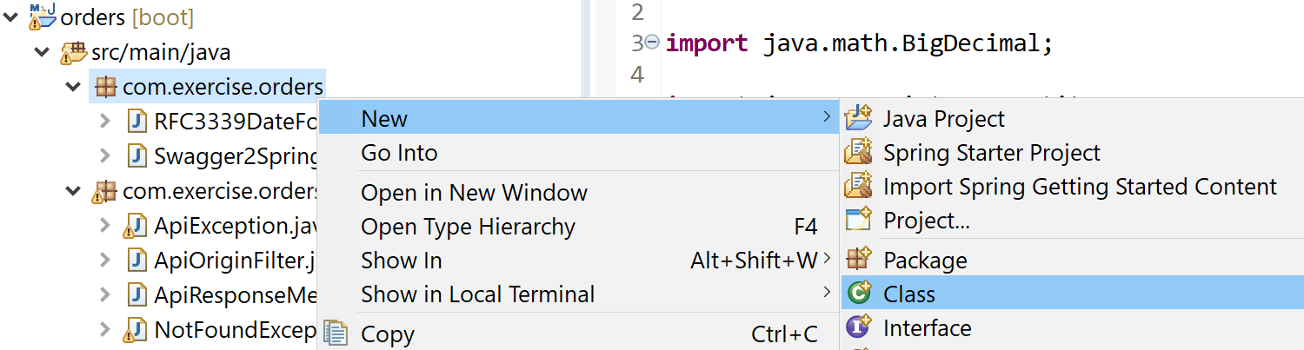

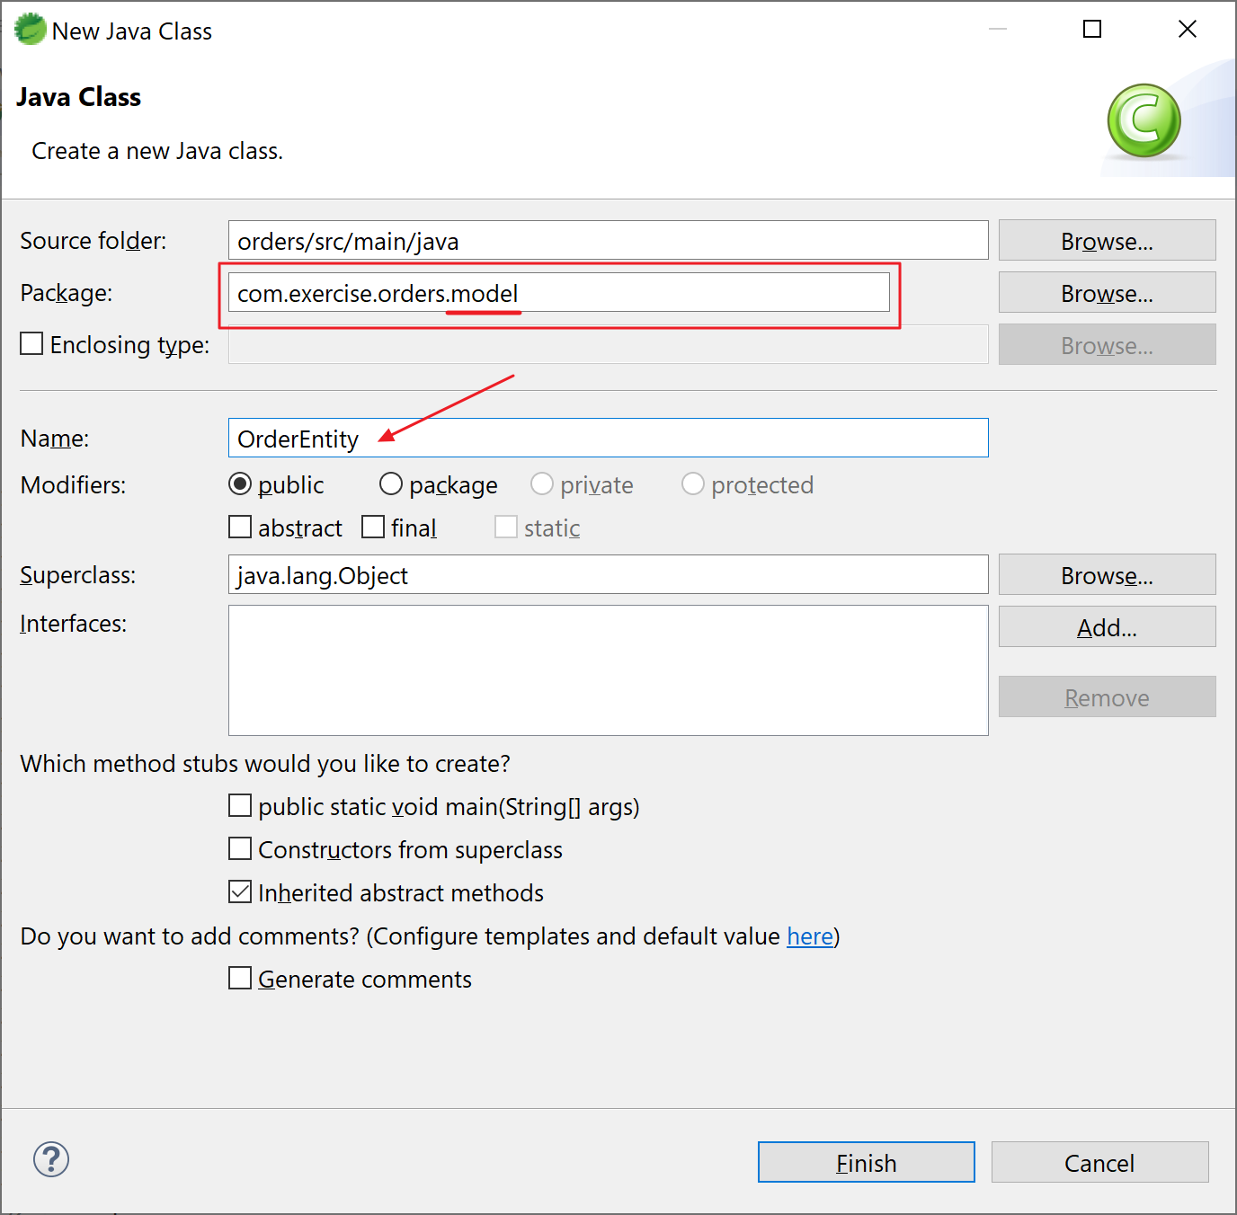

Open the file and insert the following code:

package com.exercise.orders.model;

import java.math.BigDecimal;

import javax.persistence.Entity;

import javax.persistence.GeneratedValue;

import javax.persistence.GenerationType;

import javax.persistence.Id;

import javax.persistence.Table;

@Entity

@Table(name = "orders")

public class OrderEntity {

@Id

@GeneratedValue(strategy = GenerationType.AUTO)

private Integer orderId;

private Integer userId;

private String itemCode;

private Integer quantity;

private BigDecimal unitPrice;

private String status;

public Integer getOrderId() {

return orderId;

}

public void setOrderId(Integer orderId) {

this.orderId = orderId;

}

public Integer getUserId() {

return userId;

}

public void setUserId(Integer userId) {

this.userId = userId;

}

public String getItemCode() {

return itemCode;

}

public void setItemCode(String itemCode) {

this.itemCode = itemCode;

}

public Integer getQuantity() {

return quantity;

}

public void setQuantity(Integer quantity) {

this.quantity = quantity;

}

public BigDecimal getUnitPrice() {

return unitPrice;

}

public void setUnitPrice(BigDecimal unitPrice) {

this.unitPrice = unitPrice;

}

public String getStatus() {

return status;

}

public void setStatus(String status) {

this.status = status;

}

}

13. Create the repository to access database. Create a class “OrderRepository” under package “com.exercise.orders.repository”:

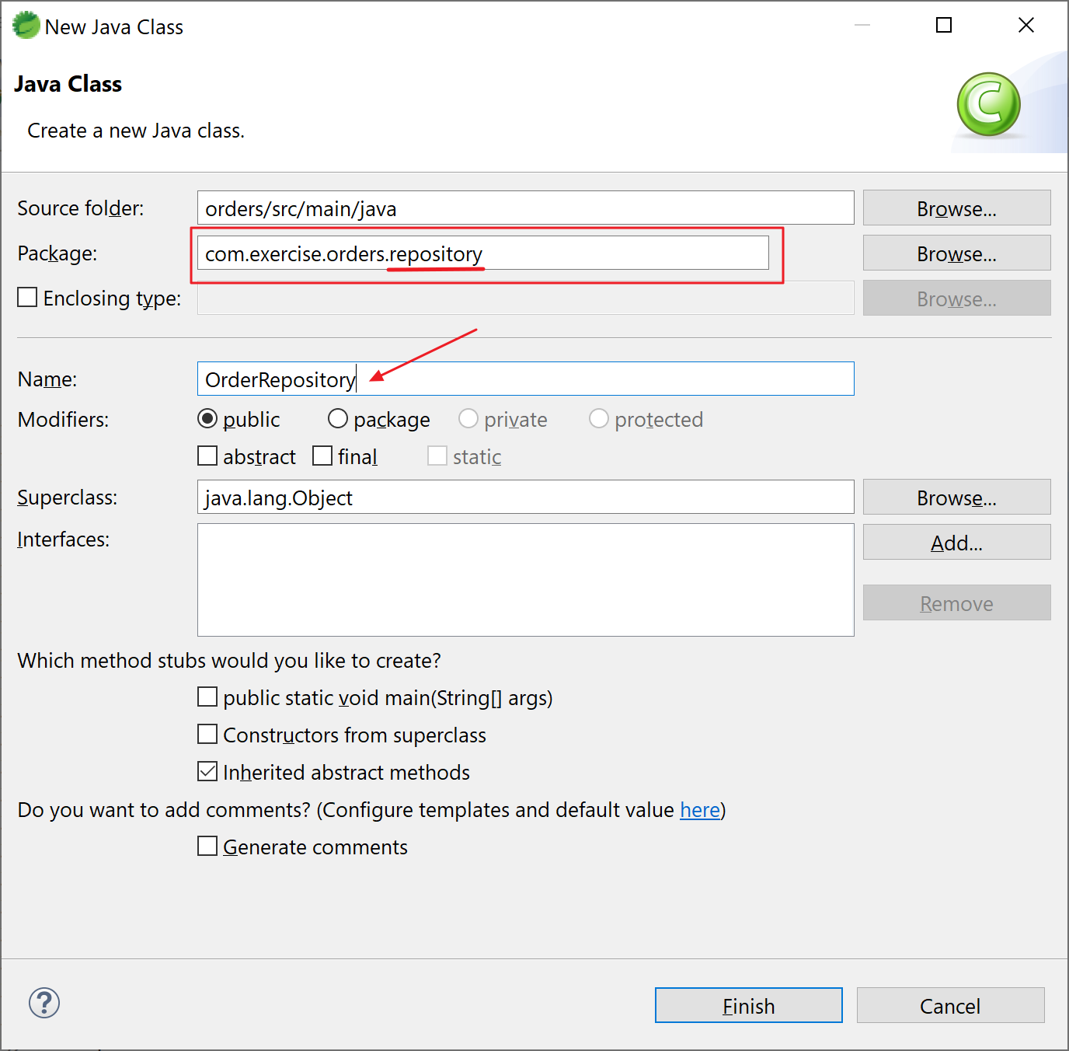

Open the file and insert the following code:

package com.exercise.orders.repository;

import org.springframework.data.jpa.repository.JpaRepository;

import com.exercise.orders.model.OrderEntity;

public interface OrderRepository extends JpaRepository<OrderEntity, String> {

public OrderEntity findByOrderId(Integer id);

}

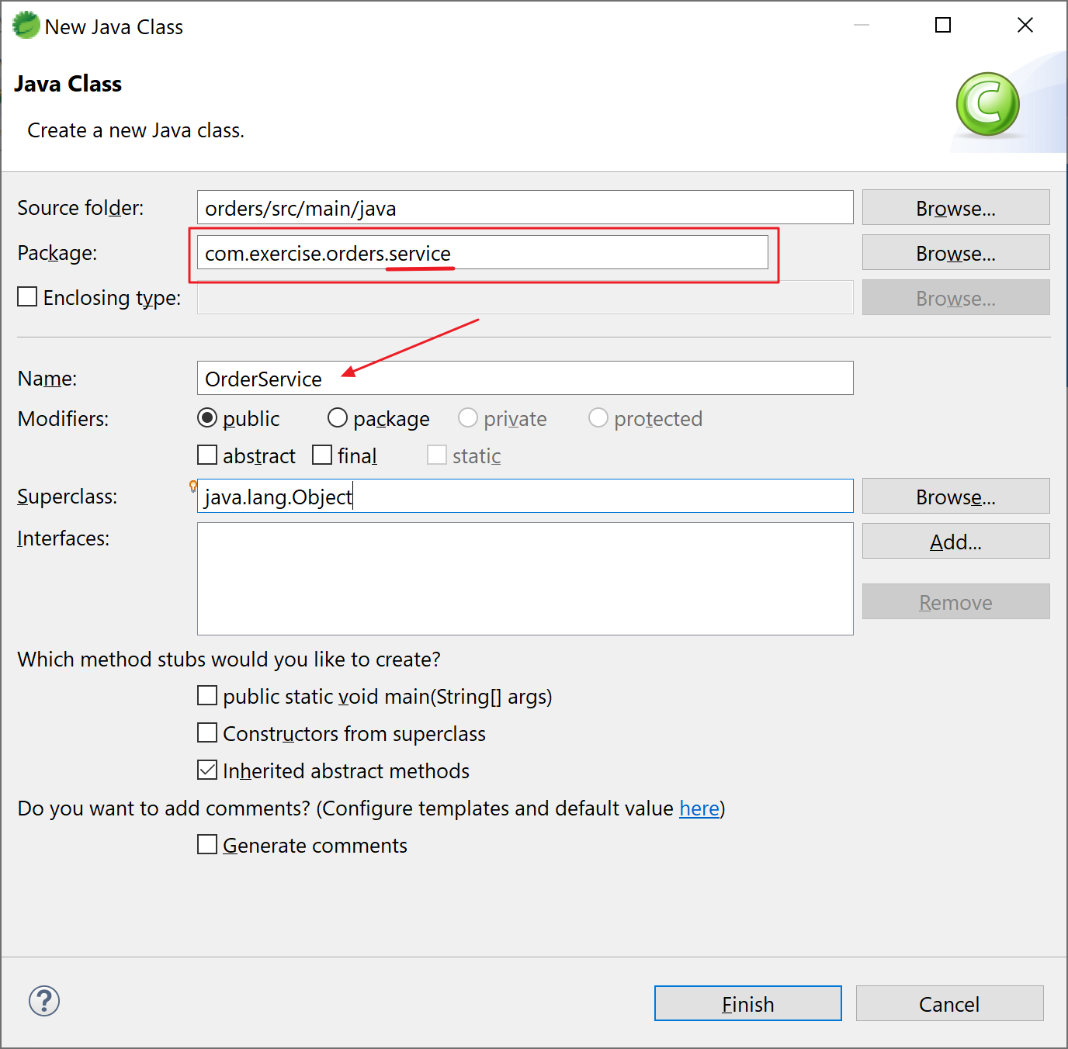14. Create the service to call the repository (instead of access database directly). Create a class “OrderService” under package “com.exercise.orders.service”:

Open the file and insert the following code:

package com.exercise.orders.service;

import java.util.List;

import org.springframework.beans.factory.annotation.Autowired;

import org.springframework.stereotype.Service;

import com.exercise.orders.model.OrderEntity;

import com.exercise.orders.repository.OrderRepository;

@Service

public class OrderService {

@Autowired

OrderRepository orderRepository;

public List<OrderEntity> getAllOrders() {

List<OrderEntity> orders = orderRepository.findAll();

return orders;

}

public OrderEntity addOrder(OrderEntity order) {

return orderRepository.save(order);

}

public OrderEntity findByOrderId(Integer id) {

return orderRepository.findByOrderId(id);

}

}

15. Implement the API functions. OrdersApiDelegate.java is an interface class that contains the API methods. Let’s create a class to implement this interface:

15a. Create a class “OrdersApiDelegateImpl” under package “com.exercise.orders.api.impl”:

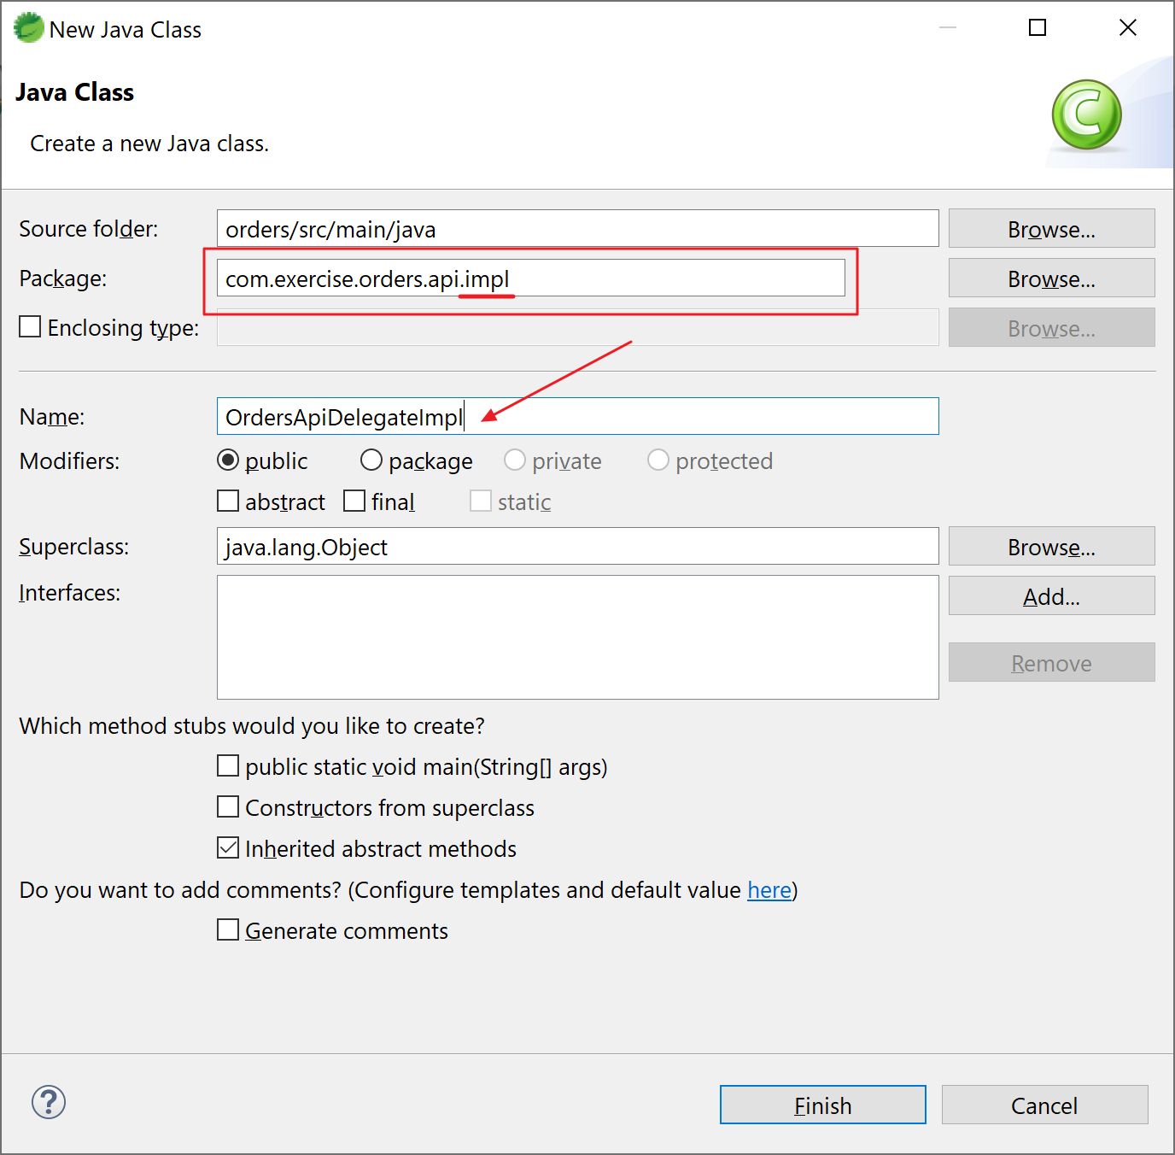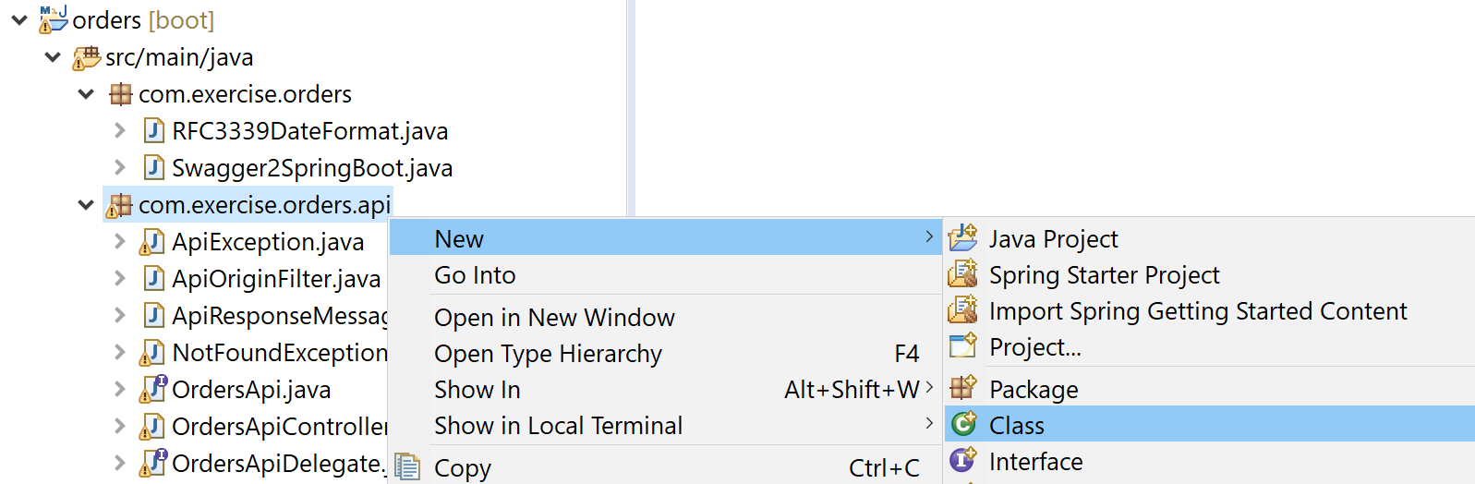

15b. Open the file “OrdersApiDelegateImpl.java” and insert the following code:

package com.exercise.orders.api.impl;

import java.util.List;

import org.springframework.beans.factory.annotation.Autowired;

import org.springframework.http.HttpStatus;

import org.springframework.http.ResponseEntity;

import com.exercise.orders.api.OrdersApiDelegate;

import com.exercise.orders.model.Order;

import com.exercise.orders.model.OrderEntity;

import com.exercise.orders.model.Orders;

import com.exercise.orders.service.OrderService;

public class OrdersApiDelegateImpl implements OrdersApiDelegate {

@Autowired

OrderService orderService;

@Override

public ResponseEntity<Order> addOrder(Order body) {

OrderEntity orderEntity = convertFrom(body);

orderEntity.setStatus("INITIAL");

orderEntity = orderService.addOrder(orderEntity);

Order order = convertFrom(orderEntity);

return new ResponseEntity<>(order, HttpStatus.OK);

}

@Override

public ResponseEntity<Orders> getAllOrders() {

List<OrderEntity> listOrderEntity = orderService.getAllOrders();

Orders orders = new Orders();

for (OrderEntity oe : listOrderEntity) {

Order order = convertFrom(oe);

orders.addDataItem(order);

}

return new ResponseEntity<>(orders, HttpStatus.OK);

}

@Override

public ResponseEntity<Order> getOrderById(Integer orderId) {

OrderEntity oe = orderService.findByOrderId(orderId);

Order order = convertFrom(oe);

return new ResponseEntity<>(order, HttpStatus.OK);

}

private OrderEntity convertFrom(Order order) {

OrderEntity orderEntity = new OrderEntity();

orderEntity.setOrderId(order.getOrderId());

orderEntity.setUserId(order.getUserId());

orderEntity.setItemCode(order.getItemCode());

orderEntity.setQuantity(order.getQuantity());

orderEntity.setUnitPrice(order.getUnitPrice());

orderEntity.setStatus(order.getStatus());

return orderEntity;

}

private Order convertFrom(OrderEntity orderEntity) {

Order order = new Order();

order.setOrderId(orderEntity.getOrderId());

order.setUserId(orderEntity.getUserId());

order.setItemCode(orderEntity.getItemCode());

order.setQuantity(orderEntity.getQuantity());

order.setUnitPrice(orderEntity.getUnitPrice());

order.setStatus(orderEntity.getStatus());

return order;

}

}

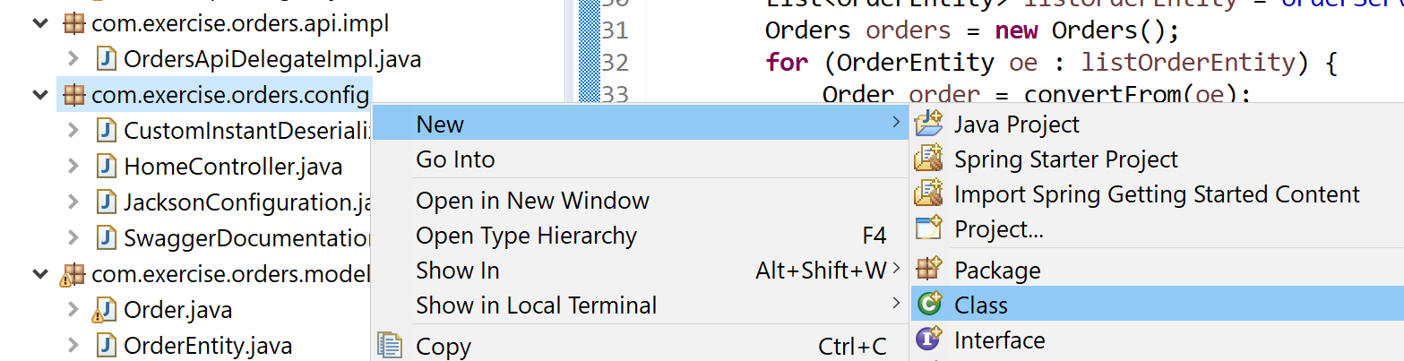14. Define the above bean. Create a class “BeanConfig” under package “com.exercise.orders.config”:

Add annotation @Configuration to the class and add the bean:

package com.exercise.orders.config;

import org.springframework.context.annotation.Bean;

import org.springframework.context.annotation.Configuration;

import com.exercise.orders.api.impl.OrdersApiDelegateImpl;

@Configuration

public class BeanConfig {

@Bean

public OrdersApiDelegateImpl ordersApi() {

return new OrdersApiDelegateImpl();

}

}

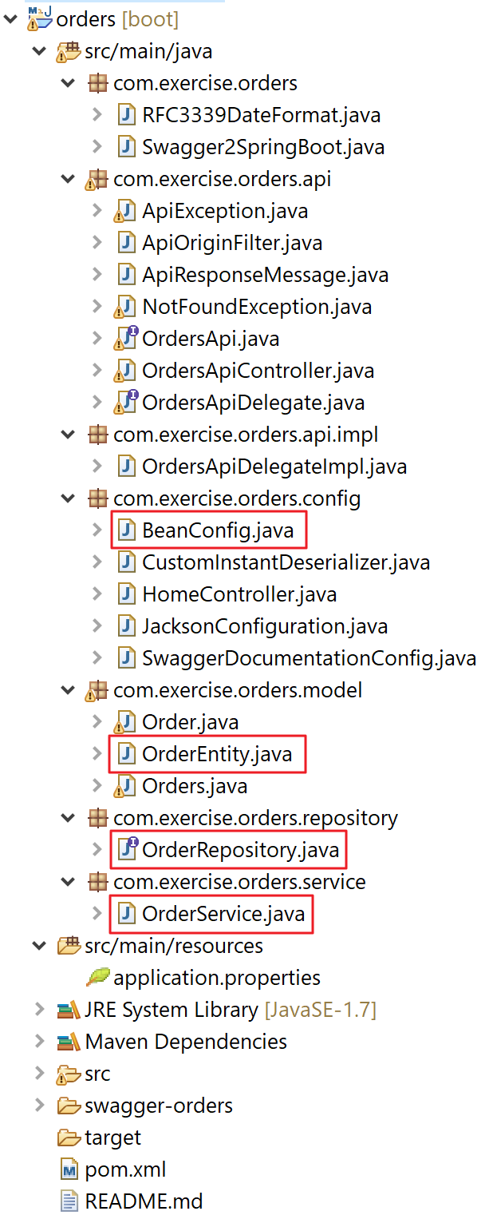Here’s the final structure of the project:

15. Start the application and xamine the application. Open a browser and visit the following URL:

<http://localhost:8080/v1/swagger-ui.html>

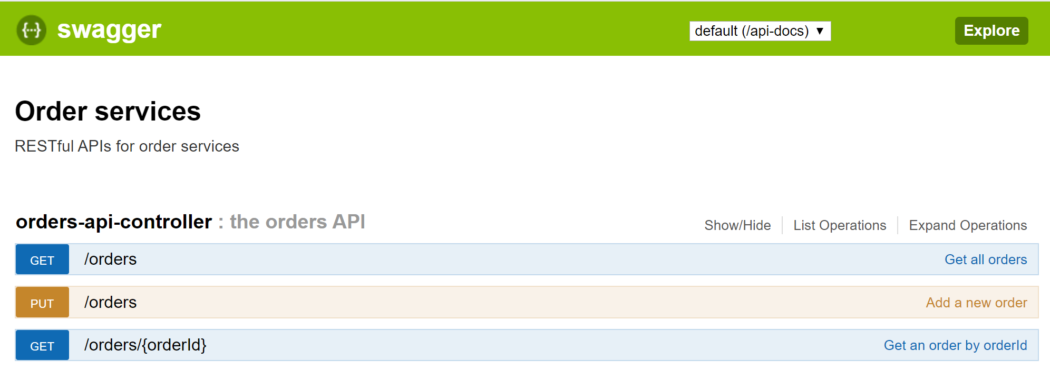

16. Congratulation! Try this one if you have problem with this exercise:



# Exercise 5 – Service to service integration

Prerequisites:

Java installed (e.g. JDK 1.8)

Maven installed (e.g. version 3.6.3)

Spring Tool Suite (STS) (e.g. 4.5.1)

Postman (e.g. version 7.20.1)

Order Service is created

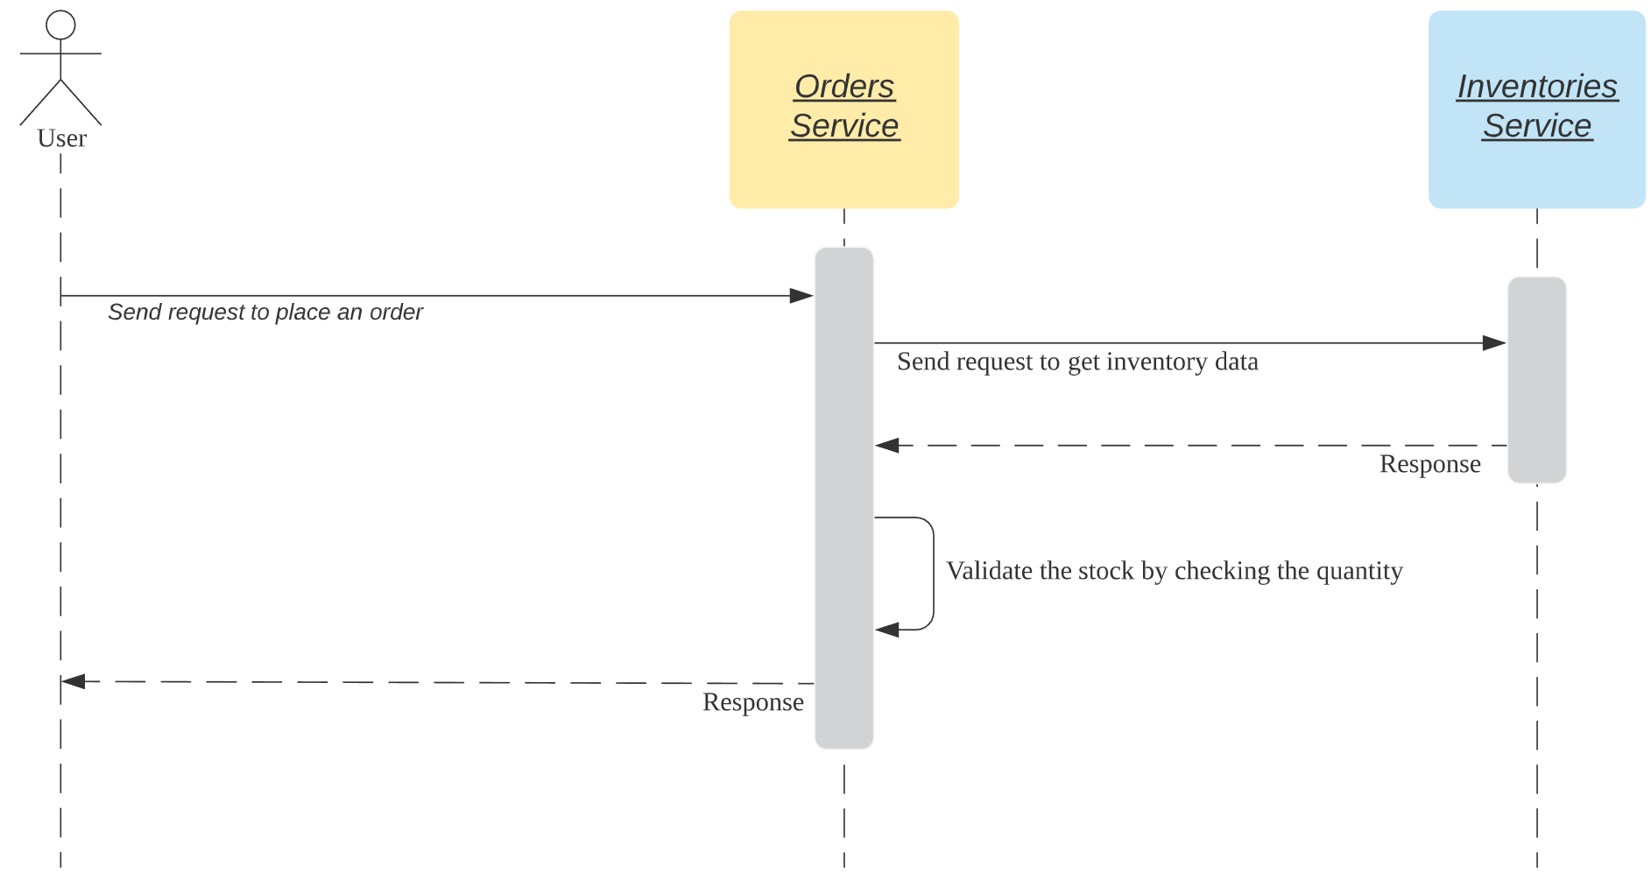

1. In this exercise, we are going to build a service (Orders Service) which in turn calling another service (Inventories Service) for a business requirement:

Note:

a. we place an order by sending request to Order service: PUT /orders/

b. Order service send a request to Inventories service to get stock info: GET /inventories/{inventoryId}

c. Order service checks the stock info and returns the response

2. Let’s modify the addOrder() in Orders service. Open OrdersApiDelegateImpl.java and modify accordingly.

2a. Before modify the code, we add the dependency to “pom.xml” first:

<dependency>

<groupId>com.googlecode.json-simple</groupId>

<artifactId>json-simple</artifactId>

<version>1.1.1</version>

</dependency>

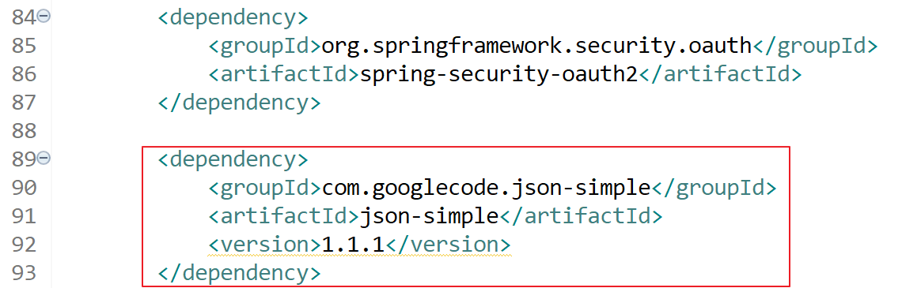

2b. Edit addOrder(), here’s the new version:

@Override

public ResponseEntity<Order> addOrder(Order body) {

final String URL_GET_INVENTORY = "http://localhost:8100/v1/inventories/1";

try {

// create auth credentials

String authStr = getCredentialsFromSecretsManager();

String base64Creds = Base64.getEncoder().encodeToString(authStr.getBytes());

// create headers

HttpHeaders headers = new HttpHeaders();

headers.add("Authorization", "Basic " + base64Creds);

// create request

HttpEntity request = new HttpEntity(headers);

// make a request

ResponseEntity<String> response = new RestTemplate().exchange(URL_GET_INVENTORY, HttpMethod.GET, request, String.class);

// get JSON response

String json = response.getBody();

HttpStatus httpStatus = response.getStatusCode();

System.out.println("############# httpStatus: " + httpStatus.toString());

// return

if (!httpStatus.is2xxSuccessful()) {

return new ResponseEntity<>(new Order(), httpStatus);

}

System.out.println("############# response json: " + json);

JSONParser parser = new JSONParser();

JSONObject jsonObject = (JSONObject) parser.parse(json);

Long quantity = (Long) jsonObject.get("quantity");

System.out.println("############# quantity: " + quantity);

// simple business logic to check quantity

if (body.getQuantity() > quantity) {

return new ResponseEntity<>(new Order(), HttpStatus.NOT_ACCEPTABLE);

}

} catch (Exception ex) {

ex.printStackTrace();

return new ResponseEntity<>(new Order(), HttpStatus.SERVICE_UNAVAILABLE);

}

OrderEntity orderEntity = convertFrom(body);

orderEntity.setStatus("INITIAL");

orderEntity = orderService.addOrder(orderEntity);

Order order = convertFrom(orderEntity);

return new ResponseEntity<>(order, HttpStatus.OK);

}

Note: we are only demonstrating the flow in this exercise, not implement the real business logic. In the above code, we just getting the first record from inventories service for simplicity. For correct implementation, we should get the corresponding record by implementing a new function in Inventories service, e.g. getInventoryByItemCode().

2c. add a new function “getCredentialsFromSecretsManager” to simulate getting credentials from Secrets Manager:

private String getCredentialsFromSecretsManager() {

// simulate the logic to get credentials from Secrets Manager

return **nameUser** + ":" + **passUser**;

}

2d. add the definitions of the variables for the above step 2c

@Value("${secrets.acl.name.user}")

private String **nameUser**;

@Value("${secrets.acl.pass.user}")

private String **passUser**;

Here’s the listing of the class “OrdersApiDelegateImpl”:

package com.exercise.orders.api.impl;

import java.util.Base64;

import java.util.List;

import org.json.simple.JSONObject;

import org.json.simple.parser.JSONParser;

import org.springframework.beans.factory.annotation.Autowired;

import org.springframework.beans.factory.annotation.Value;

import org.springframework.http.HttpEntity;

import org.springframework.http.HttpHeaders;

import org.springframework.http.HttpMethod;

import org.springframework.http.HttpStatus;

import org.springframework.http.ResponseEntity;

import org.springframework.web.client.RestTemplate;

import com.exercise.orders.api.OrdersApiDelegate;

import com.exercise.orders.model.Order;

import com.exercise.orders.model.OrderEntity;

import com.exercise.orders.model.Orders;

import com.exercise.orders.service.OrderService;

public class OrdersApiDelegateImpl implements OrdersApiDelegate {

@Autowired

OrderService orderService;

@Value("${secrets.acl.name.user}")

private String nameUser;

@Value("${secrets.acl.pass.user}")

private String passUser;

@Override

public ResponseEntity<Order> addOrder(Order body) {

final String URL_GET_INVENTORY = "http://localhost:8100/v1/inventories/1";

try {

// create auth credentials

String authStr = getCredentialsFromSecretsManager();

String base64Creds = Base64.getEncoder().encodeToString(authStr.getBytes());

// create headers

HttpHeaders headers = new HttpHeaders();

headers.add("Authorization", "Basic " + base64Creds);

// create request

HttpEntity request = new HttpEntity(headers);

// make a request

ResponseEntity<String> response = new RestTemplate().exchange(URL_GET_INVENTORY, HttpMethod.GET, request, String.class);

// get JSON response

String json = response.getBody();

HttpStatus httpStatus = response.getStatusCode();

System.out.println("############# httpStatus: " + httpStatus.toString());

// return

if (!httpStatus.is2xxSuccessful()) {

return new ResponseEntity<>(new Order(), httpStatus);

}

System.out.println("############# response json: " + json);

JSONParser parser = new JSONParser();

JSONObject jsonObject = (JSONObject) parser.parse(json);

Long quantity = (Long) jsonObject.get("quantity");

System.out.println("############# quantity: " + quantity);

// simple business logic to check quantity

if (body.getQuantity() > quantity) {

return new ResponseEntity<>(new Order(), HttpStatus.NOT_ACCEPTABLE);

}

} catch (Exception ex) {

ex.printStackTrace();

return new ResponseEntity<>(new Order(), HttpStatus.SERVICE_UNAVAILABLE);

}

OrderEntity orderEntity = convertFrom(body);

orderEntity.setStatus("INITIAL");

orderEntity = orderService.addOrder(orderEntity);

Order order = convertFrom(orderEntity);

return new ResponseEntity<>(order, HttpStatus.OK);

}

@Override

public ResponseEntity<Orders> getAllOrders() {

List<OrderEntity> listOrderEntity = orderService.getAllOrders();

Orders orders = new Orders();

for (OrderEntity oe : listOrderEntity) {

Order order = convertFrom(oe);

orders.addDataItem(order);

}

return new ResponseEntity<>(orders, HttpStatus.OK);

}

@Override

public ResponseEntity<Order> getOrderById(Integer orderId) {

OrderEntity oe = orderService.findByOrderId(orderId);

Order order = convertFrom(oe);

return new ResponseEntity<>(order, HttpStatus.OK);

}

private OrderEntity convertFrom(Order order) {

OrderEntity orderEntity = new OrderEntity();

orderEntity.setOrderId(order.getOrderId());

orderEntity.setUserId(order.getUserId());

orderEntity.setItemCode(order.getItemCode());

orderEntity.setQuantity(order.getQuantity());

orderEntity.setUnitPrice(order.getUnitPrice());

orderEntity.setStatus(order.getStatus());

return orderEntity;

}

private Order convertFrom(OrderEntity orderEntity) {

Order order = new Order();

order.setOrderId(orderEntity.getOrderId());

order.setUserId(orderEntity.getUserId());

order.setItemCode(orderEntity.getItemCode());

order.setQuantity(orderEntity.getQuantity());

order.setUnitPrice(orderEntity.getUnitPrice());

order.setStatus(orderEntity.getStatus());

return order;

}

private String getCredentialsFromSecretsManager() {

// simulate the logic to get credentials from Secrets Manager

return nameUser + ":" + passUser;

}

}

2e. Define the values in “application.properties” that used in above step 2d:

# simulate secrets manager for user

secrets.acl.name.user=user

secrets.acl.pass.user=password1

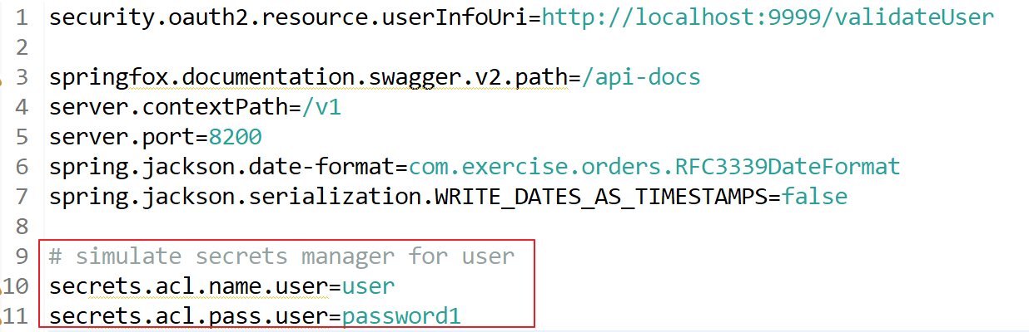

Note: the values of secrets.acl.name.user and secrets.acl.pass.user define here (Orders service) should be the same as the values in Inventories service.

2g. Change the port to 8200 for order services:

server.port=8200

3. The code is done. Let’s examine the API.

4. Start the Inventories service (if we don’t start it yet). Open a new command prompt and go to the root directory of Inventories service project, e.g.:

cd C:\java-ex\ms-swagger\inventories

5. Run the following command:

C:\java-ex\ms-swagger\inventories>**mvn spring-boot:run**



Note: Inventories service is on port 8100

6. Start / restart the Orders services. Open a new command prompt and go to the root directory of Orders service project, e.g.:

cd C:\java-ex\ms-swagger\orders

7. Run the following command:

C:\java-ex\ms-swagger\orders>**mvn spring-boot:run**



Note: Orders service is on port 8200

Both services should start:

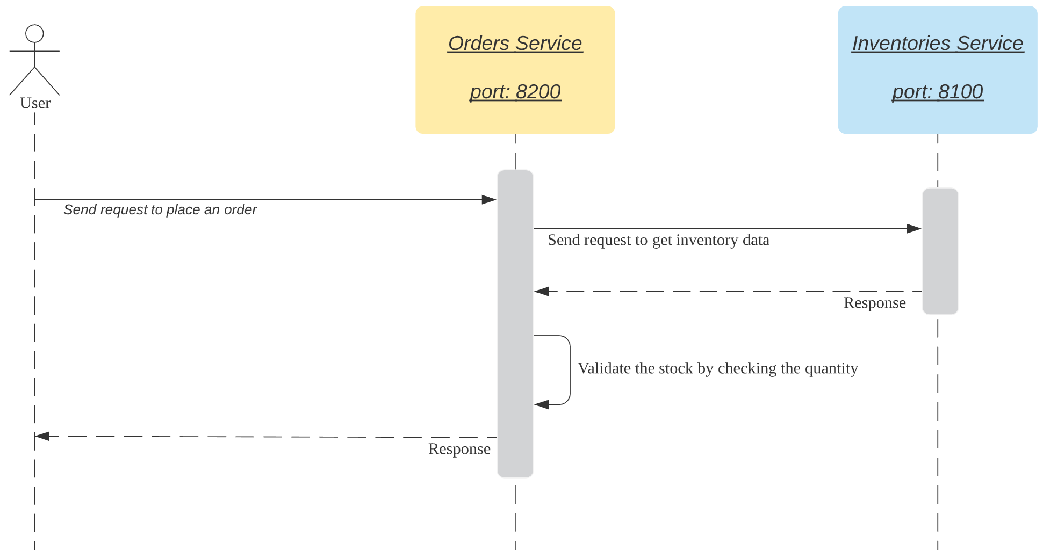

9. Add stock to the Inventories service first. Open Postman and input the following data:

PUT http://localhost:8100/v1/inventories

Username: admin

Password: password2

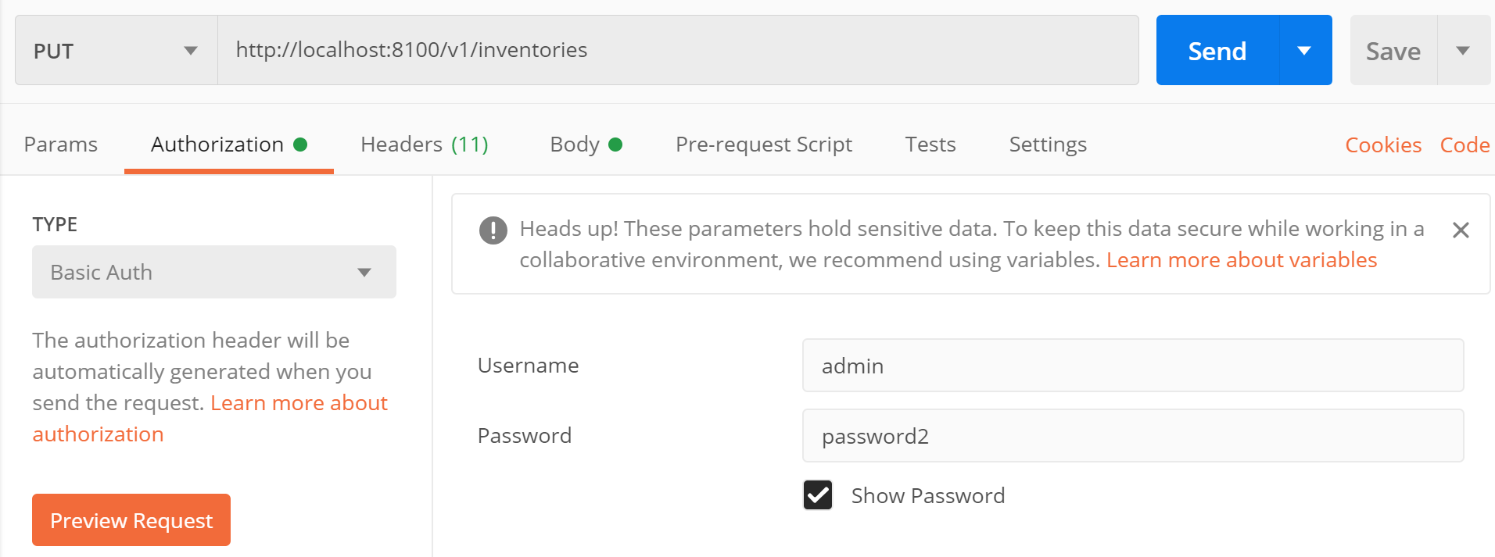

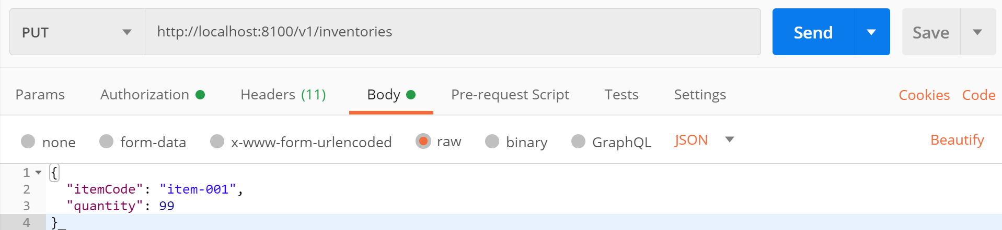In Body tag, input the following JSON:

10. Click Send button. Now you add a stock “item-001” with quantity 99 through the Inventory service. You may try to get the response with the following request:

GET http://localhost:8100/v1/inventories

You should get the following response:

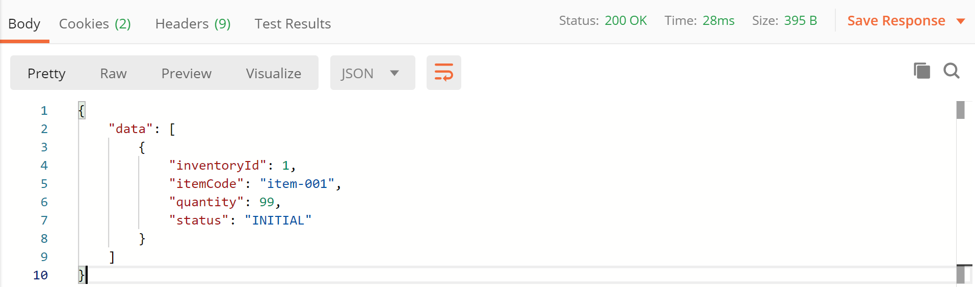

11. Send a request to our newly modified API to Orders service. Create the following request in Postman:

PUT localhost:8200/v1/orders/

In the Body tag, input the following JSON:

{

"userId": 1,

"itemCode": "item-001",

"quantity": 1,

"unitPrice": 123.99

}

P.S Remember add **Content-Type** with value **Application/json** in request header

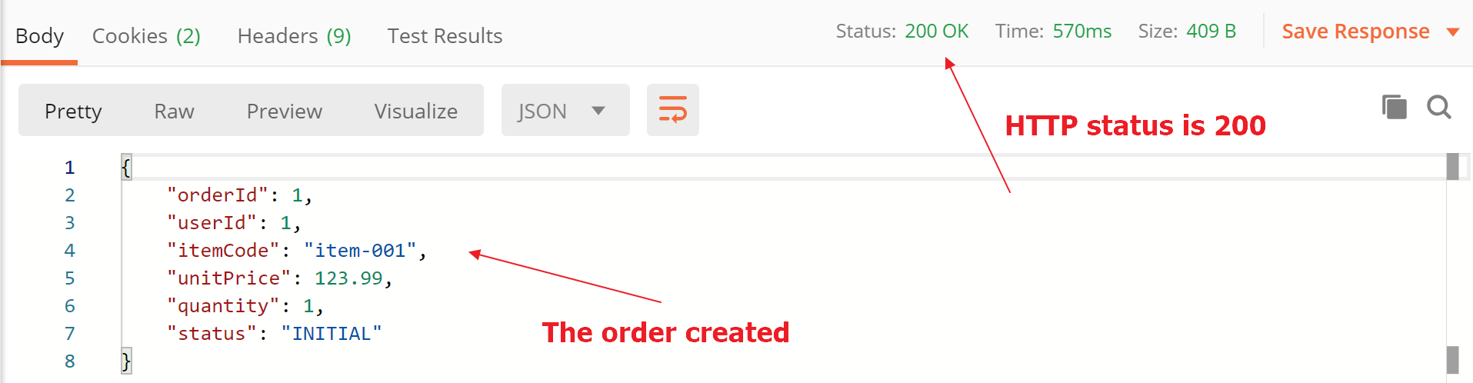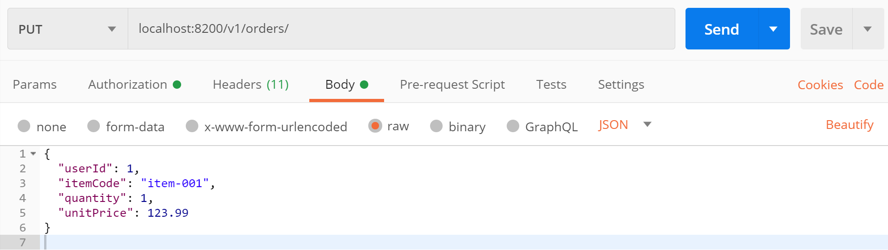Click Send button and the order should created:

12. Try to place an order with quantity 100. Open Postman and input the following data:

In Body tag, input the following JSON:

{

"userId": 1,

"itemCode": "item-001",

"quantity": 100,

"unitPrice": 123.99

}

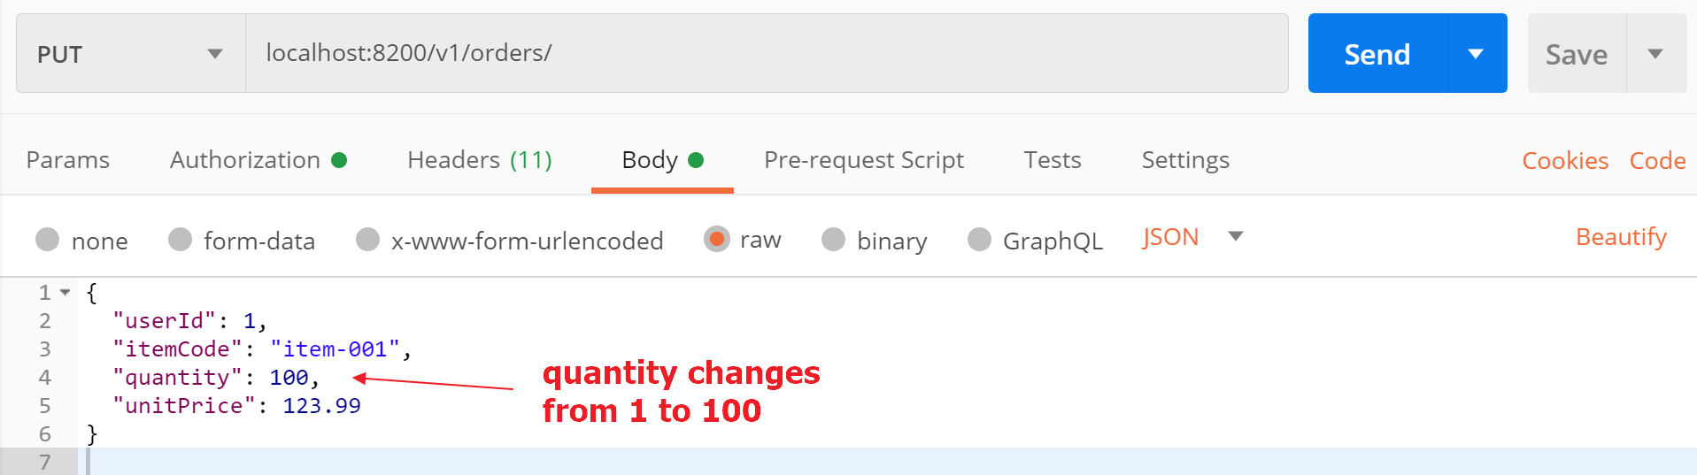

Note: changes quantity value to 100

Click Send button:

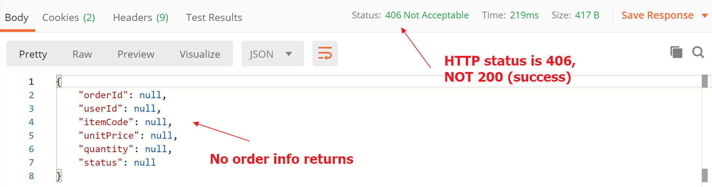

Note: the quantity from Inventories server returns 99, but our new order requests 100. The response shows the API call is not performed and returns HTTP status other than 200.

13. Congratulations! Try this one if you have problem with this exercise:



# Exercise 6 – microservices (logging)

Prerequisites:

Java installed (e.g. JDK 1.8)

Maven installed (e.g. version 3.6.3)

Spring Tool Suite (STS) (e.g. 4.5.1)

Exercise 3 is finished

1. Debugging is a challenge in developing microservices. In this exercise, we walk through the steps to log our messages and we will revisit the logs in other exercises.

2. Add the following dependencies to Order service’s “pom.xml”:

<dependency>

<groupId>ch.qos.logback</groupId>

<artifactId>logback-classic</artifactId>

<version>1.2.3</version>

</dependency>

<dependency>

<groupId>net.logstash.logback</groupId>

<artifactId>logstash-logback-encoder</artifactId>

<version>6.3</version>

</dependency>

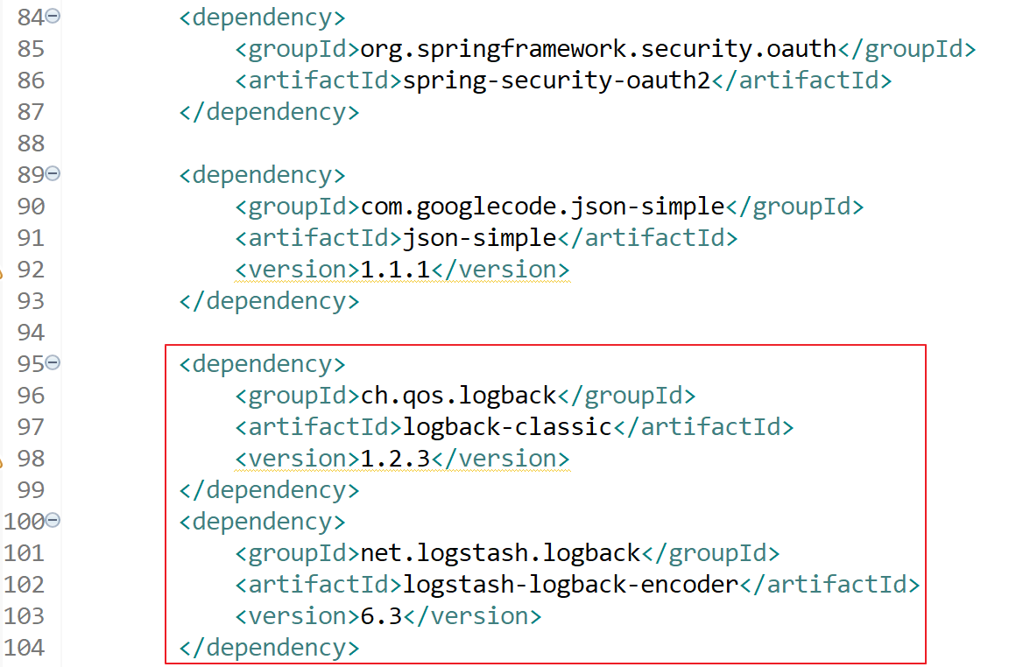

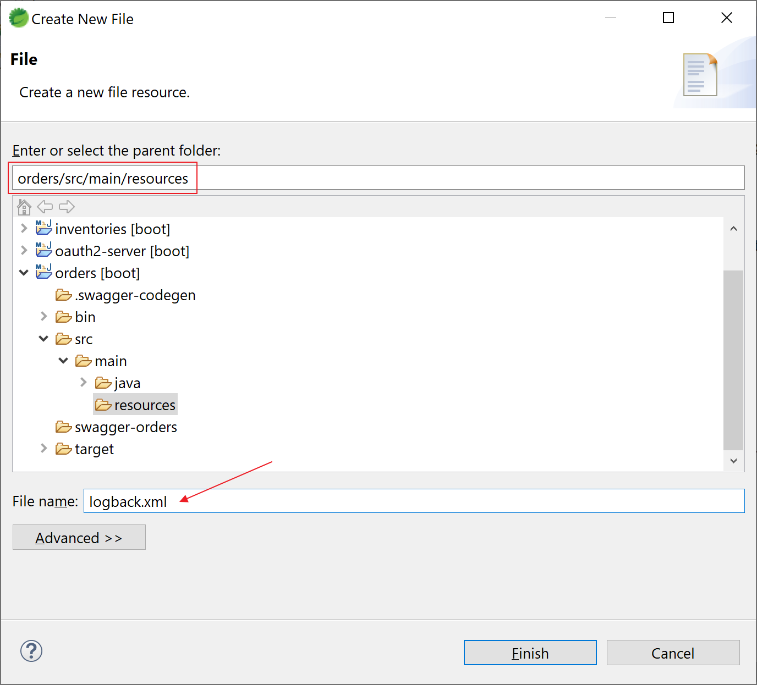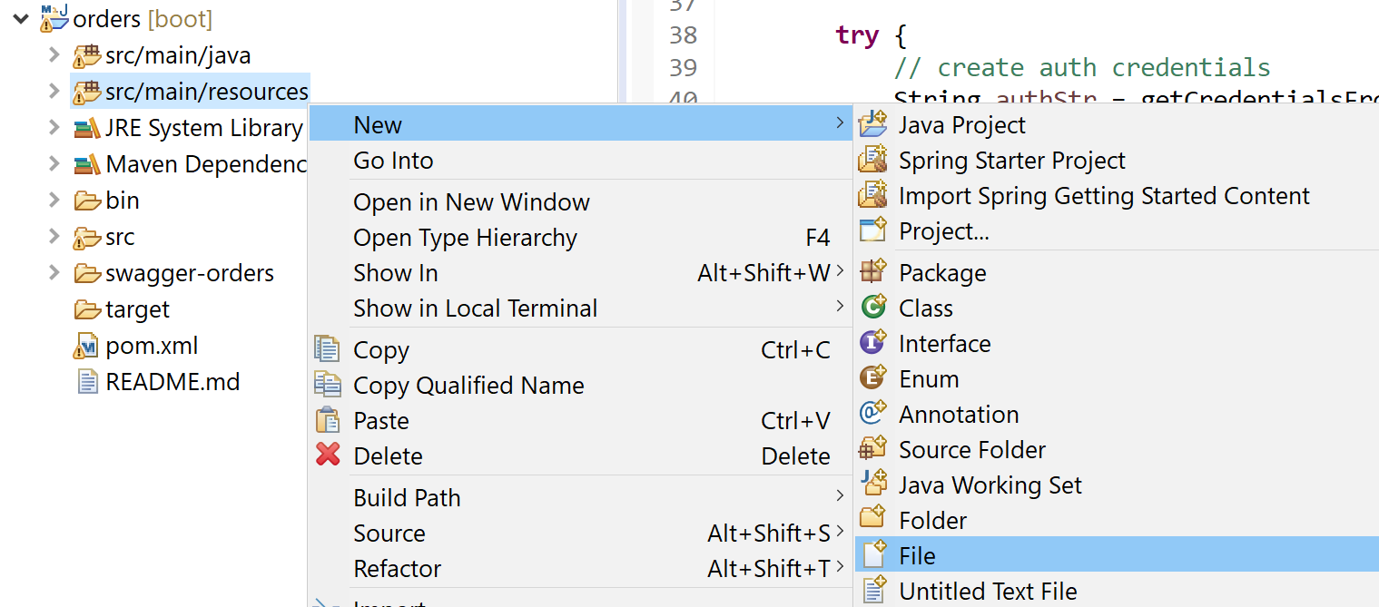3. Add a configuration file “logback.xml” under ”src/main/resources”:

Here’s the content of “logback.xml”:

<configuration>

<appender name="STDOUT" class="ch.qos.logback.core.ConsoleAppender">

<encoder class="**net.logstash.logback.encoder.LogstashEncoder**">

<includeMdcKeyName>mdc</includeMdcKeyName>

</encoder>

</appender>

<root level="debug">

<appender-ref ref="STDOUT" />

</root>

</configuration>

Note: we're using the LogstashEncoder to do the encoding into a JSON format which is easier to use with Logstash.

4. The configuration is done, then “how to log our messages?”. Open “OrdersApiDelegateImpl.java” and modify accordingly.

4a. declare the logger with this code:

private static final Logger logger = LoggerFactory.getLogger(OrdersApiDelegateImpl.class);

4b. use the logger to log your messages, e.g.:

logger.info("############# httpStatus: " + httpStatus.toString());

Note: you may use other logging levels to log the messages, e.g. logger.debug(“hello”);

4c. change System.out.println() to logger.info():

package com.exercise.orders.api.impl;

import java.util.Base64;

import java.util.List;

import org.json.simple.JSONObject;

import org.json.simple.parser.JSONParser;

import org.slf4j.Logger;

import org.slf4j.LoggerFactory;

import org.springframework.beans.factory.annotation.Autowired;

import org.springframework.beans.factory.annotation.Value;

import org.springframework.http.HttpEntity;

import org.springframework.http.HttpHeaders;

import org.springframework.http.HttpMethod;

import org.springframework.http.HttpStatus;

import org.springframework.http.ResponseEntity;

import org.springframework.web.client.RestTemplate;

import com.exercise.orders.api.OrdersApiDelegate;

import com.exercise.orders.model.Order;

import com.exercise.orders.model.OrderEntity;

import com.exercise.orders.model.Orders;

import com.exercise.orders.service.OrderService;

public class OrdersApiDelegateImpl implements OrdersApiDelegate {

private static final Logger logger = LoggerFactory.getLogger(OrdersApiDelegateImpl.class);

@Autowired

OrderService orderService;

@Value("${secrets.acl.name.user}")

private String nameUser;

@Value("${secrets.acl.pass.user}")

private String passUser;

@Override

public ResponseEntity<Order> addOrder(Order body) {

final String URL_GET_INVENTORY = "http://localhost:8100/v1/inventories/1";

try {

// create auth credentials

String authStr = getCredentialsFromSecretsManager();

String base64Creds = Base64.getEncoder().encodeToString(authStr.getBytes());

// create headers

HttpHeaders headers = new HttpHeaders();

headers.add("Authorization", "Basic " + base64Creds);

// create request

HttpEntity request = new HttpEntity(headers);

// make a request

ResponseEntity<String> response = new RestTemplate().exchange(URL_GET_INVENTORY, HttpMethod.GET, request, String.class);

// get JSON response

String json = response.getBody();

HttpStatus httpStatus = response.getStatusCode();

**logger.info("############# httpStatus: " + httpStatus.toString());**

// return

if (!httpStatus.is2xxSuccessful()) {

return new ResponseEntity<>(new Order(), httpStatus);

}

**logger.info("############# response json: " + json);**

JSONParser parser = new JSONParser();

JSONObject jsonObject = (JSONObject) parser.parse(json);

Long quantity = (Long) jsonObject.get("quantity");

**logger.info("############# quantity: " + quantity);**

// simple business logic to check quantity

if (body.getQuantity() > quantity) {

return new ResponseEntity<>(new Order(), HttpStatus.NOT_ACCEPTABLE);

}

} catch (Exception ex) {

ex.printStackTrace();

return new ResponseEntity<>(new Order(), HttpStatus.SERVICE_UNAVAILABLE);

}

OrderEntity orderEntity = convertFrom(body);

orderService.addOrder(orderEntity);

orderEntity.setStatus("INITIAL");

Order order = convertFrom(orderEntity);

return new ResponseEntity<>(order, HttpStatus.OK);

}

@Override

public ResponseEntity<Orders> getAllOrders() {

List<OrderEntity> listOrderEntity = orderService.getAllOrders();

Orders orders = new Orders();

for (OrderEntity oe : listOrderEntity) {

Order order = convertFrom(oe);

orders.addDataItem(order);

}

return new ResponseEntity<>(orders, HttpStatus.OK);

}

@Override

public ResponseEntity<Order> getOrderById(Integer orderId) {

OrderEntity oe = orderService.findByOrderId(orderId);

Order order = convertFrom(oe);

return new ResponseEntity<>(order, HttpStatus.OK);

}

private OrderEntity convertFrom(Order order) {

OrderEntity orderEntity = new OrderEntity();

orderEntity.setOrderId(order.getOrderId());

orderEntity.setUserId(order.getUserId());

orderEntity.setItemCode(order.getItemCode());

orderEntity.setQuantity(order.getQuantity());

orderEntity.setUnitPrice(order.getUnitPrice());

orderEntity.setStatus(order.getStatus());

return orderEntity;

}

private Order convertFrom(OrderEntity orderEntity) {

Order order = new Order();

order.setOrderId(orderEntity.getOrderId());

order.setUserId(orderEntity.getUserId());

order.setItemCode(orderEntity.getItemCode());

order.setQuantity(orderEntity.getQuantity());

order.setUnitPrice(orderEntity.getUnitPrice());

order.setStatus(orderEntity.getStatus());

return order;

}

private String getCredentialsFromSecretsManager() {

// simulate the logic to get credentials from Secrets Manager

return nameUser + ":" + passUser;

}

}

Note: you may add your own log in the code.

5. Restart the Orders service.

6. Try to send some requests to the Orders service and view the log in the command prompt of the Orders services:

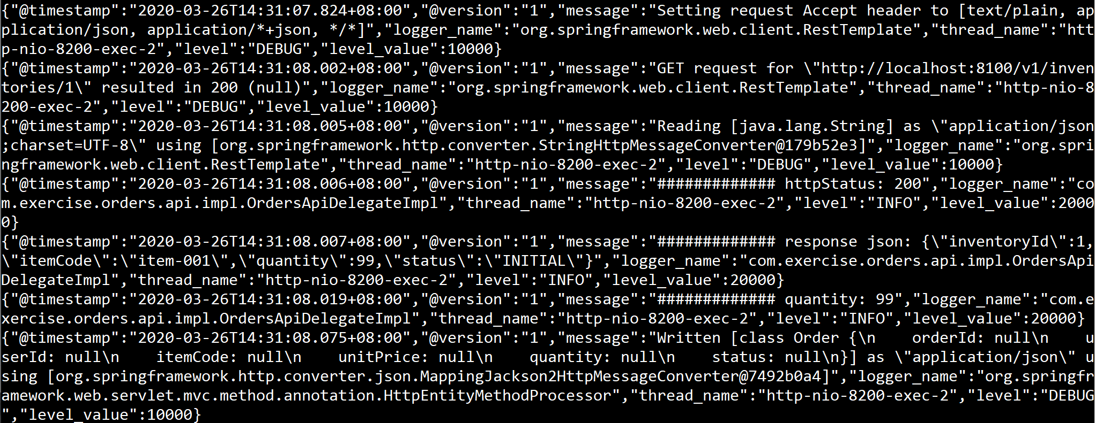Examples of the log messages:

Note: the log should be in JSON format.

7. You try run the same put request to add the same order multiple times and review the log. Are you able to distinguish the logs? You may try to add MDC context there and to see the differences.

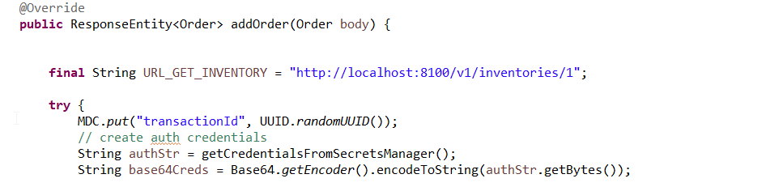7a. Add MDC.put(“transactionId”, UUID.randomUUID()); in addOrder() method

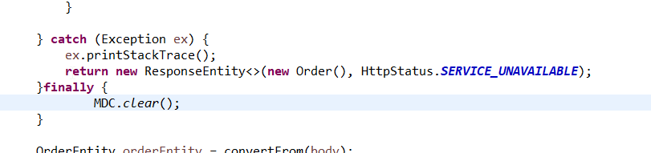7b. Add MDC.clear() at the end of the try{} block.

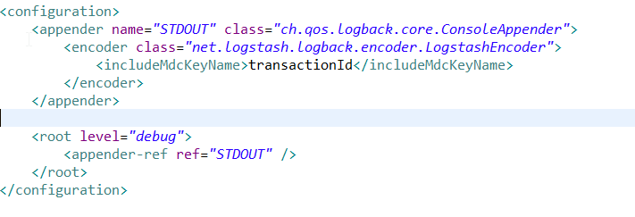7c. Modify the logback.xml to print MDC key transactionId in the log message

7d. Restart the service and test again.

8. Congratulations! Try this one if you have problem with this exercise:



~ End of the exercises ~